AI Models Test Report - Error Analysis

# Summary

Total testing time: 2182.51 seconds

Total models tested: 1146

Successful models: 1146

Average error across all models: 91.049060

# Detailed Results by Function

## Function: Ackley

Dimensions: 3D -> 1D

Formula: -20exp(-0.2sqrt((x^2+y^2+z^2)/3)) - exp((cos(6.28x)+cos(6.28y)+cos(6.28z))/3) + 20 + e

|  |  |  |  |  |  |  |  |  |  |  |
| --- | --- | --- | --- | --- | --- | --- | --- | --- | --- | --- |
| Model Type | 10 samples | 20 samples | 50 samples | 100 samples | 200 samples | 500 samples | 1000 samples | 2000 samples | 5000 samples | 10000 samples |
| nn | 153.42% | 336.33% | 102.74% | 177.66% | 146.27% | 102.87% | 269.67% | 198.32% | 207.12% | 352.88% |
| prbf | 1043.24% | 169.48% | 140.06% | 98.32% | 76.15% | 153.63% | 59.34% | 48.90% | 48.81% | 53.62% |
| rbf | 1467.01% | 1451.25% | 1460.14% | 1408.92% | 1327.51% | 1144.90% | 835.05% | 379.24% | 62.81% | 56.13% |
| rf | 180.15% | 155.10% | 110.38% | 84.93% | 65.12% | 98.00% | 53.40% | 46.00% | 52.59% | 51.38% |

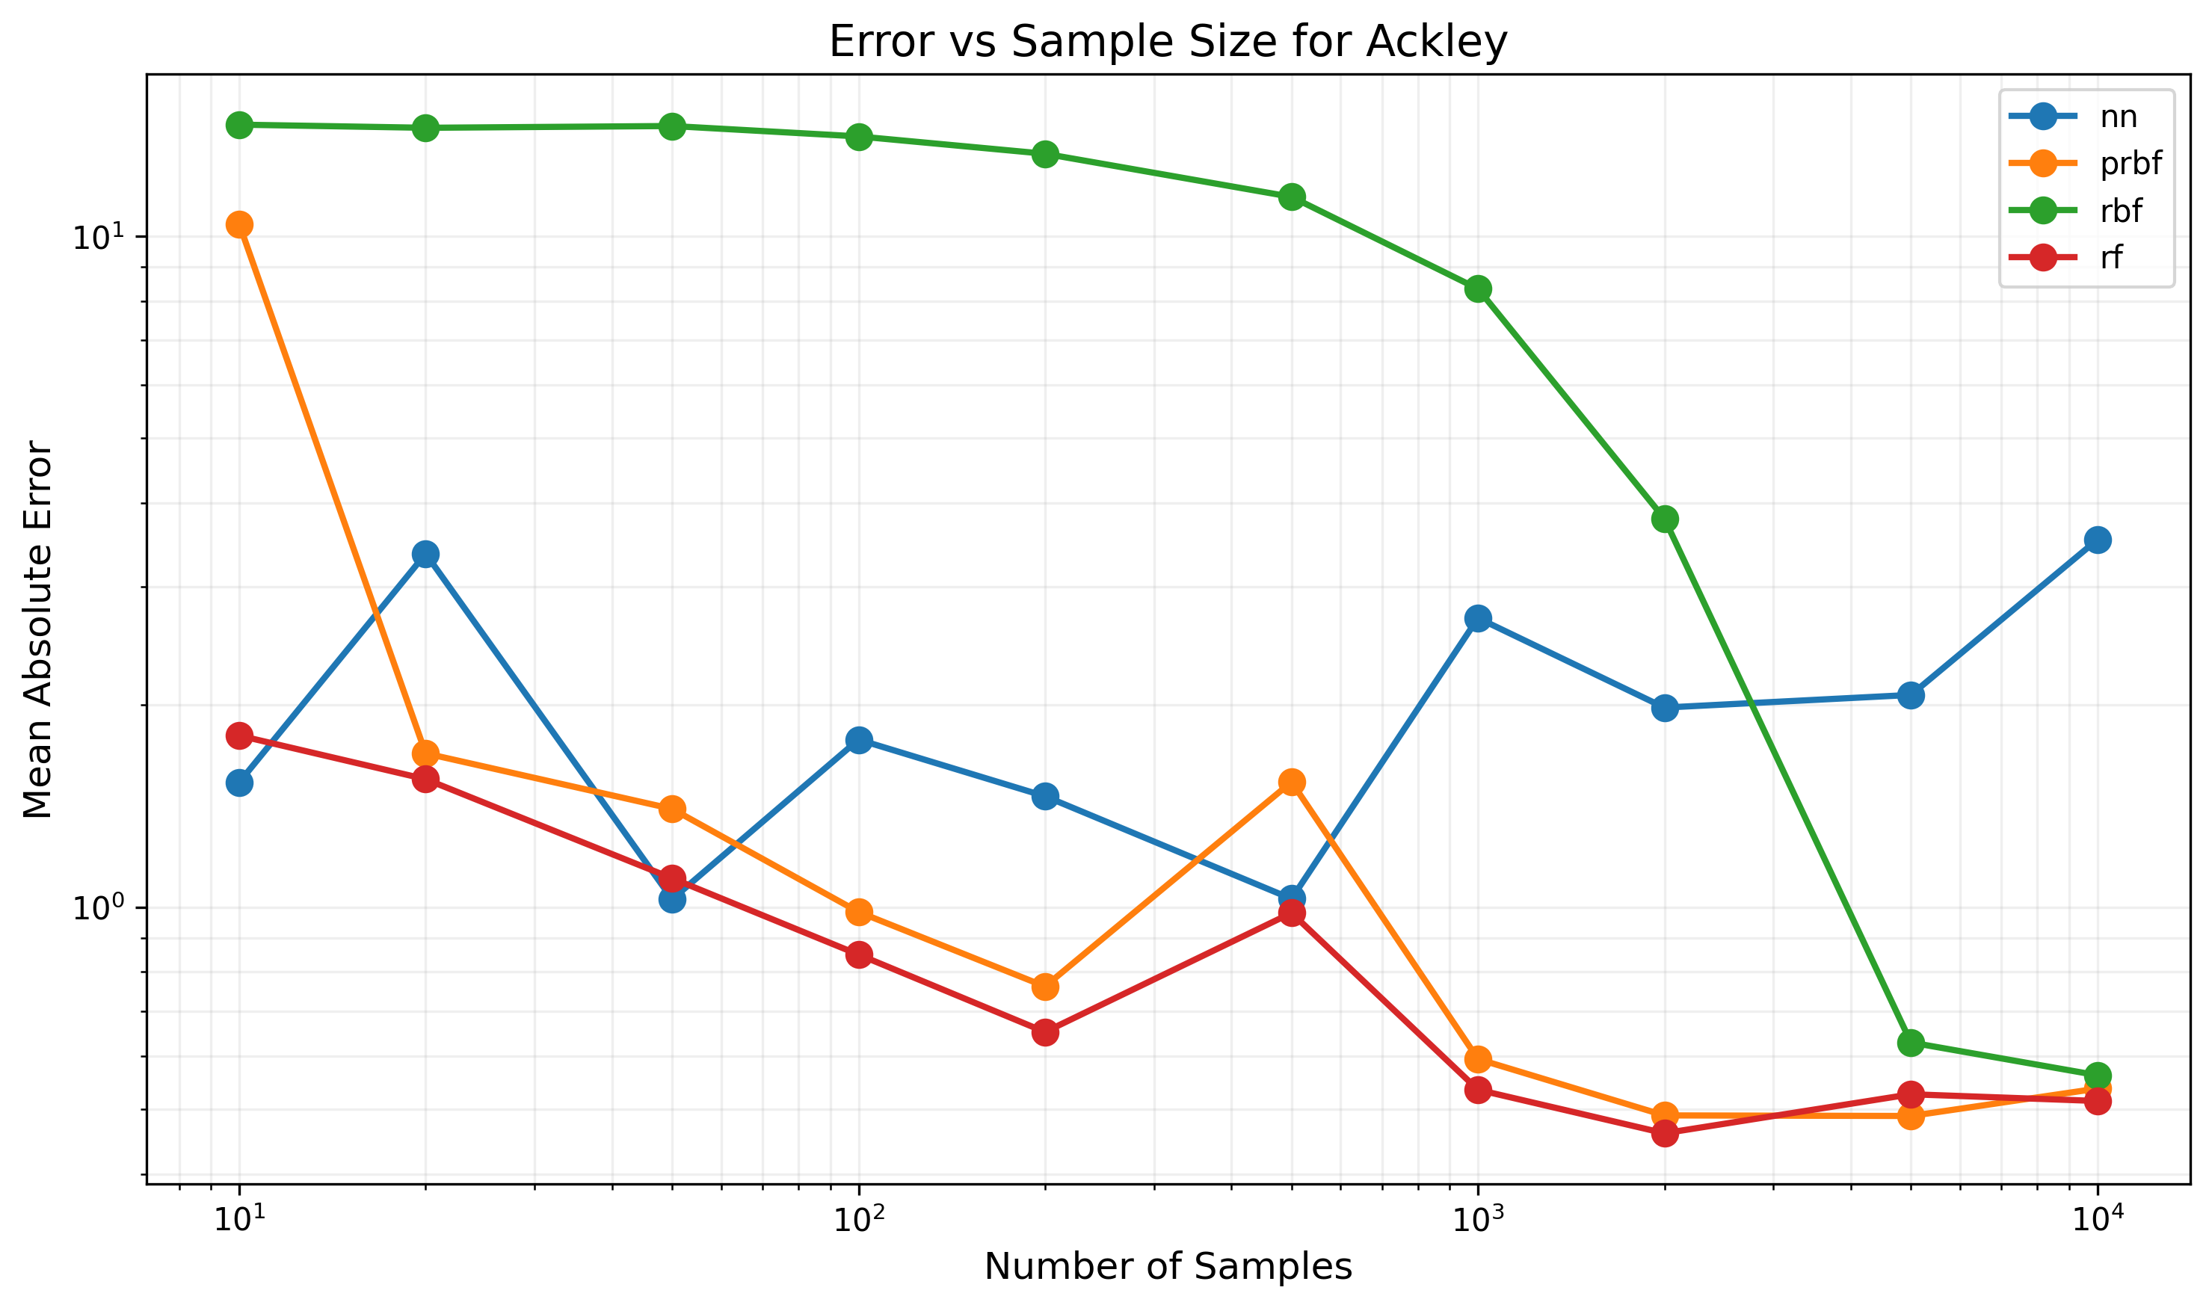

Figure: Error trends for Ackley function

## Function: Exponential

Dimensions: 3D -> 1D

Formula: exp(0.1x) + exp(0.1y) + exp(0.1z)

|  |  |  |  |  |  |  |  |  |  |  |
| --- | --- | --- | --- | --- | --- | --- | --- | --- | --- | --- |
| Model Type | 10 samples | 20 samples | 50 samples | 100 samples | 200 samples | 500 samples | 1000 samples | 2000 samples | 5000 samples | 10000 samples |
| nn | 44.79% | 40.21% | 31.92% | 49.36% | 45.36% | 37.65% | 37.15% | 38.64% | 37.33% | 38.90% |
| prbf | 56.11% | 6.45% | 5.25% | 4.89% | 3.85% | 3.01% | 2.27% | 1.09% | 0.24% | 0.13% |
| rbf | 344.60% | 348.09% | 348.17% | 332.51% | 316.38% | 265.77% | 199.91% | 88.70% | 10.13% | 5.11% |
| rf | 52.64% | 36.22% | 29.51% | 18.54% | 14.03% | 8.70% | 6.69% | 5.53% | 4.02% | 3.94% |

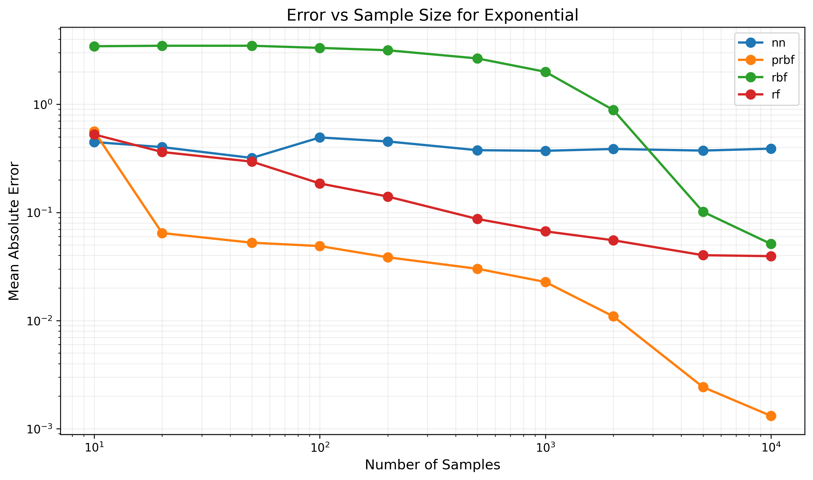

Figure: Error trends for Exponential function

## Function: Gaussian_2D

Dimensions: 2D -> 1D

Formula: exp(-(x^2 + y^2)/2)

|  |  |  |  |  |  |  |  |
| --- | --- | --- | --- | --- | --- | --- | --- |
| Model Type | 10 samples | 20 samples | 50 samples | 100 samples | 200 samples | 500 samples | 1000 samples |
| nn | 29.57% | 1.94% | 3.54% | 2.84% | 7.79% | 15.92% | 16.23% |
| prbf | 20.16% | 1.89% | 1.97% | 2.12% | 1.08% | 0.14% | 0.01% |
| rbf | 0.75% | 2.15% | 0.84% | 1.25% | 0.31% | 0.07% | 0.00% |
| rf | 19.12% | 2.82% | 1.62% | 1.78% | 1.06% | 0.60% | 0.27% |

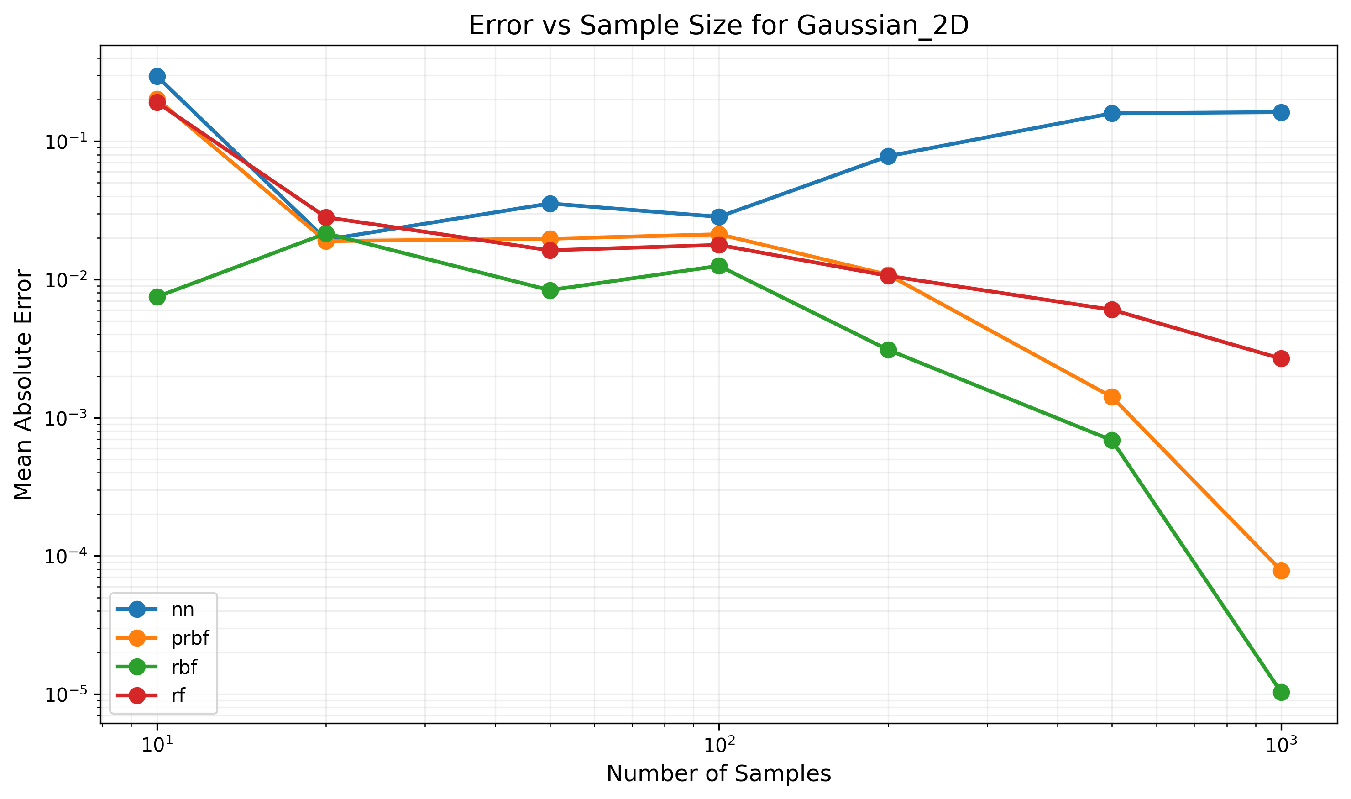

Figure: Error trends for Gaussian_2D function

## Function: HyperSphere_4D

Dimensions: 4D -> 1D

Formula: x1^2 + x2^2 + x3^2 + x4^2

|  |  |  |  |  |  |  |  |  |  |  |
| --- | --- | --- | --- | --- | --- | --- | --- | --- | --- | --- |
| Model Type | 10 samples | 20 samples | 50 samples | 100 samples | 200 samples | 500 samples | 1000 samples | 2000 samples | 5000 samples | 10000 samples |
| nn | 12694.93% | 5706.17% | 6082.50% | 2593.19% | 2679.20% | 3780.70% | 3371.86% | 3210.36% | 3652.66% | 2581.85% |
| prbf | FAIL | 0.03% | 0.02% | 0.02% | 0.02% | 0.02% | 0.02% | 0.02% | 0.02% | 0.02% |
| rbf | 13256.15% | 13470.68% | 13447.11% | 13279.71% | 13142.20% | 13098.82% | 12769.92% | 12316.29% | 10871.54% | 8454.49% |
| rf | 6289.70% | 7091.38% | 3944.04% | 2117.38% | 1949.70% | 1809.56% | 1707.80% | 1980.65% | 1877.52% | 1527.02% |

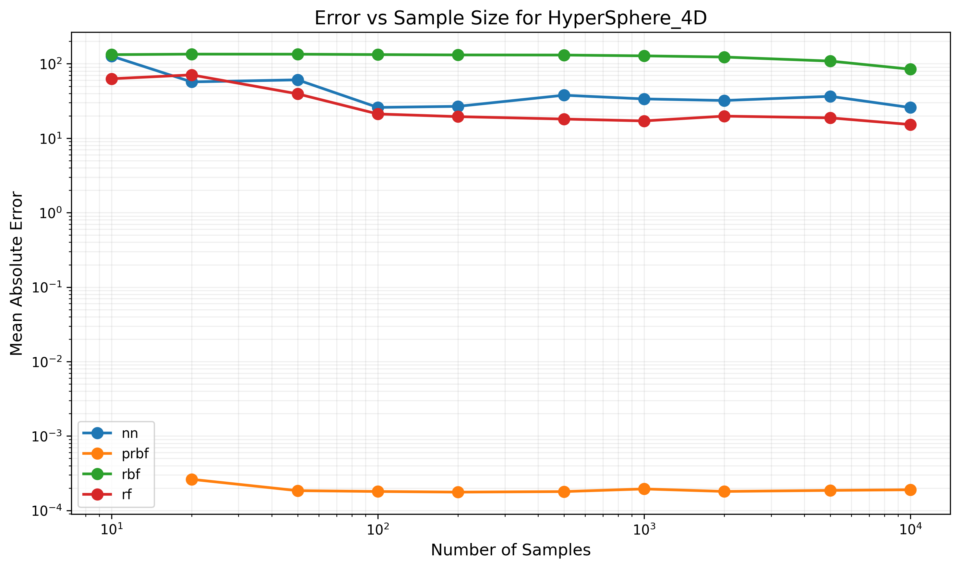

Figure: Error trends for HyperSphere_4D function

## Function: HyperSphere_5D

Dimensions: 5D -> 1D

Formula: x1^2 + x2^2 + x3^2 + x4^2 + x5^2

|  |  |  |  |  |  |  |  |  |  |  |
| --- | --- | --- | --- | --- | --- | --- | --- | --- | --- | --- |
| Model Type | 10 samples | 20 samples | 50 samples | 100 samples | 200 samples | 500 samples | 1000 samples | 2000 samples | 5000 samples | 10000 samples |
| nn | 20384.32% | 17004.13% | 8915.28% | 3506.75% | 2872.48% | 5498.35% | 5126.15% | 6235.91% | 5681.90% | 4946.98% |
| prbf | FAIL | FAIL | 0.02% | 0.02% | 0.03% | 0.02% | 0.02% | 0.02% | 0.02% | 0.02% |
| rbf | 16242.70% | 16631.69% | 16696.30% | 16455.95% | 16506.22% | 16809.68% | 16490.78% | 16010.88% | 16354.30% | 16051.44% |
| rf | 10177.83% | 7254.89% | 4485.71% | 4234.84% | 3040.65% | 2604.16% | 2748.44% | 2594.09% | 2551.00% | 2861.85% |

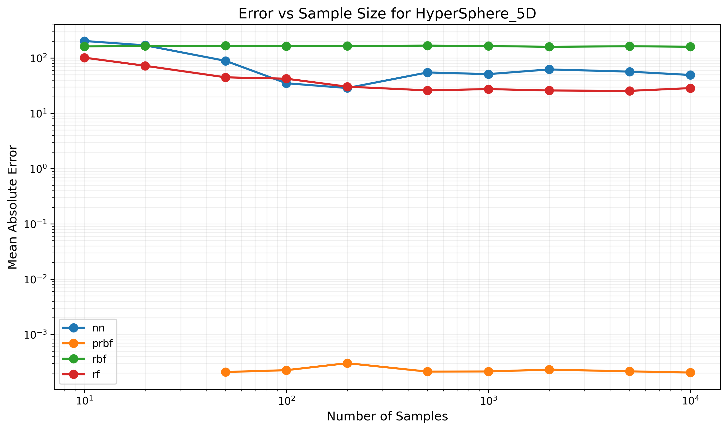

Figure: Error trends for HyperSphere_5D function

## Function: Hyperbolic

Dimensions: 3D -> 1D

Formula: tanh(x) + tanh(y) + tanh(z)

|  |  |  |  |  |  |  |  |  |  |  |
| --- | --- | --- | --- | --- | --- | --- | --- | --- | --- | --- |
| Model Type | 10 samples | 20 samples | 50 samples | 100 samples | 200 samples | 500 samples | 1000 samples | 2000 samples | 5000 samples | 10000 samples |
| nn | 61.64% | 59.80% | 61.73% | 104.90% | 95.91% | 53.42% | 81.45% | 73.21% | 69.15% | 74.31% |
| prbf | 249.90% | 65.91% | 66.88% | 57.66% | 52.12% | 44.66% | 32.44% | 16.02% | 2.24% | 0.91% |
| rbf | 137.83% | 136.85% | 136.16% | 131.79% | 126.89% | 105.80% | 81.00% | 37.31% | 4.38% | 1.72% |
| rf | 111.39% | 75.98% | 39.08% | 19.16% | 8.62% | 5.89% | 4.80% | 3.08% | 2.24% | 1.83% |

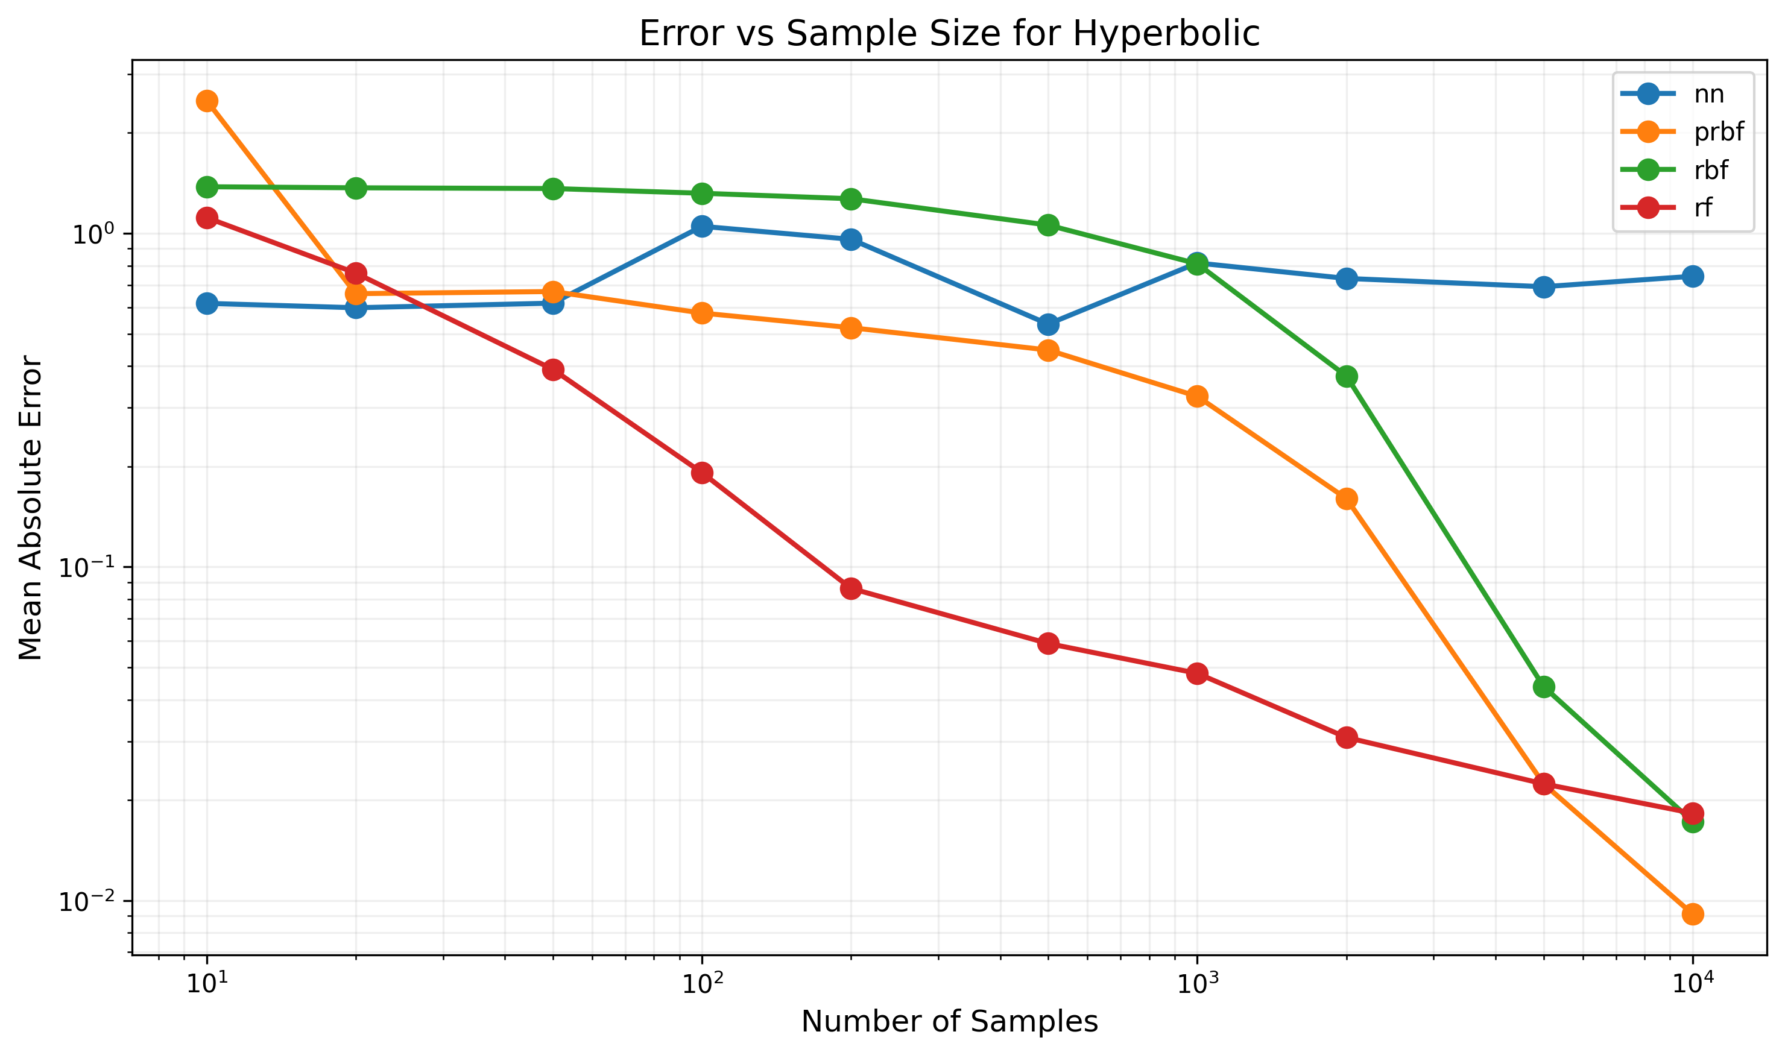

Figure: Error trends for Hyperbolic function

## Function: Linear_1D

Dimensions: 1D -> 1D

Formula: 2x + 1

|  |  |  |  |  |  |  |  |  |  |  |
| --- | --- | --- | --- | --- | --- | --- | --- | --- | --- | --- |
| Model Type | 10 samples | 20 samples | 50 samples | 100 samples | 200 samples | 500 samples | 1000 samples | 2000 samples | 5000 samples | 10000 samples |
| nn | 225.00% | 196.29% | 84.42% | 416.76% | 432.08% | 502.07% | 362.39% | 420.94% | 402.17% | 454.98% |
| prbf | 0.00% | 0.00% | 0.00% | 0.00% | 0.00% | 0.00% | 0.00% | 0.00% | 0.00% | 0.00% |
| rbf | 213.65% | 15.30% | 0.56% | 0.29% | 0.19% | 0.12% | 0.08% | 0.06% | 0.03% | 0.03% |
| rf | 67.35% | 33.07% | 11.95% | 5.65% | 2.90% | 1.13% | 0.56% | 0.28% | 0.14% | 0.11% |

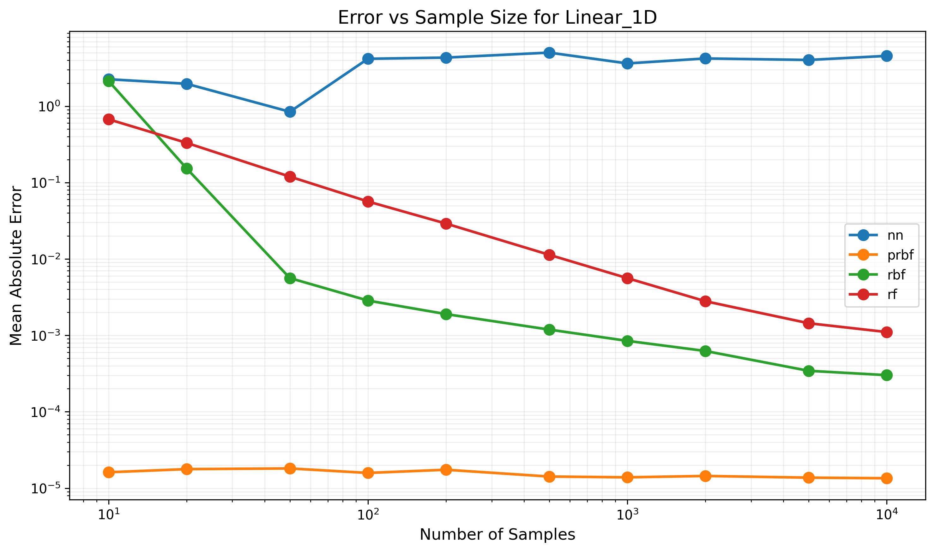

Figure: Error trends for Linear_1D function

## Function: Linear_2D

Dimensions: 2D -> 1D

Formula: x + 2y + 1

|  |  |  |  |  |  |  |  |
| --- | --- | --- | --- | --- | --- | --- | --- |
| Model Type | 10 samples | 20 samples | 50 samples | 100 samples | 200 samples | 500 samples | 1000 samples |
| nn | 319.50% | 598.91% | 210.94% | 429.69% | 595.76% | 527.42% | 526.65% |
| prbf | 0.00% | 0.00% | 0.00% | 0.00% | 0.00% | 0.00% | 0.00% |
| rbf | 1014.66% | 991.59% | 813.47% | 571.63% | 189.92% | 21.00% | 5.23% |
| rf | 298.61% | 273.53% | 143.53% | 86.23% | 69.86% | 33.08% | 20.13% |

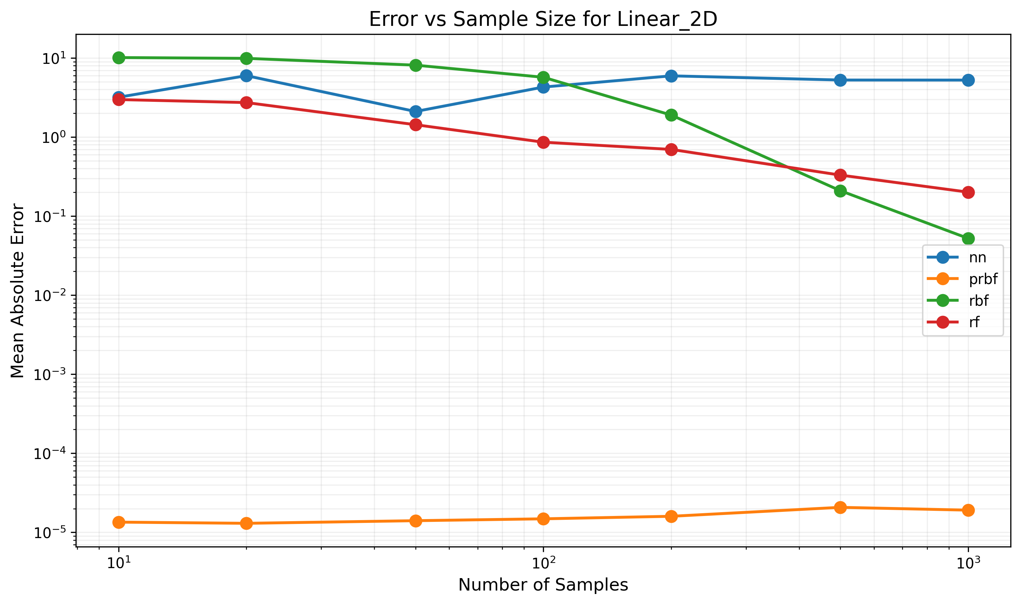

Figure: Error trends for Linear_2D function

## Function: Linear_4D

Dimensions: 4D -> 1D

Formula: x1 + 2x2 + 3x3 + 4x4 + 1

|  |  |  |  |  |  |  |  |  |  |  |
| --- | --- | --- | --- | --- | --- | --- | --- | --- | --- | --- |
| Model Type | 10 samples | 20 samples | 50 samples | 100 samples | 200 samples | 500 samples | 1000 samples | 2000 samples | 5000 samples | 10000 samples |
| nn | 554.71% | 620.45% | 1110.76% | 1228.92% | 1216.01% | 984.63% | 1066.61% | 1364.89% | 1134.28% | 1213.76% |
| prbf | FAIL | 0.00% | 0.00% | 0.00% | 0.00% | 0.00% | 0.00% | 0.00% | 0.00% | 0.00% |
| rbf | 2546.41% | 2536.90% | 2508.48% | 2606.68% | 2515.03% | 2504.83% | 2427.52% | 2356.96% | 2138.98% | 1737.22% |
| rf | 1511.38% | 1133.38% | 776.24% | 631.18% | 469.29% | 362.21% | 307.41% | 265.56% | 216.70% | 193.64% |

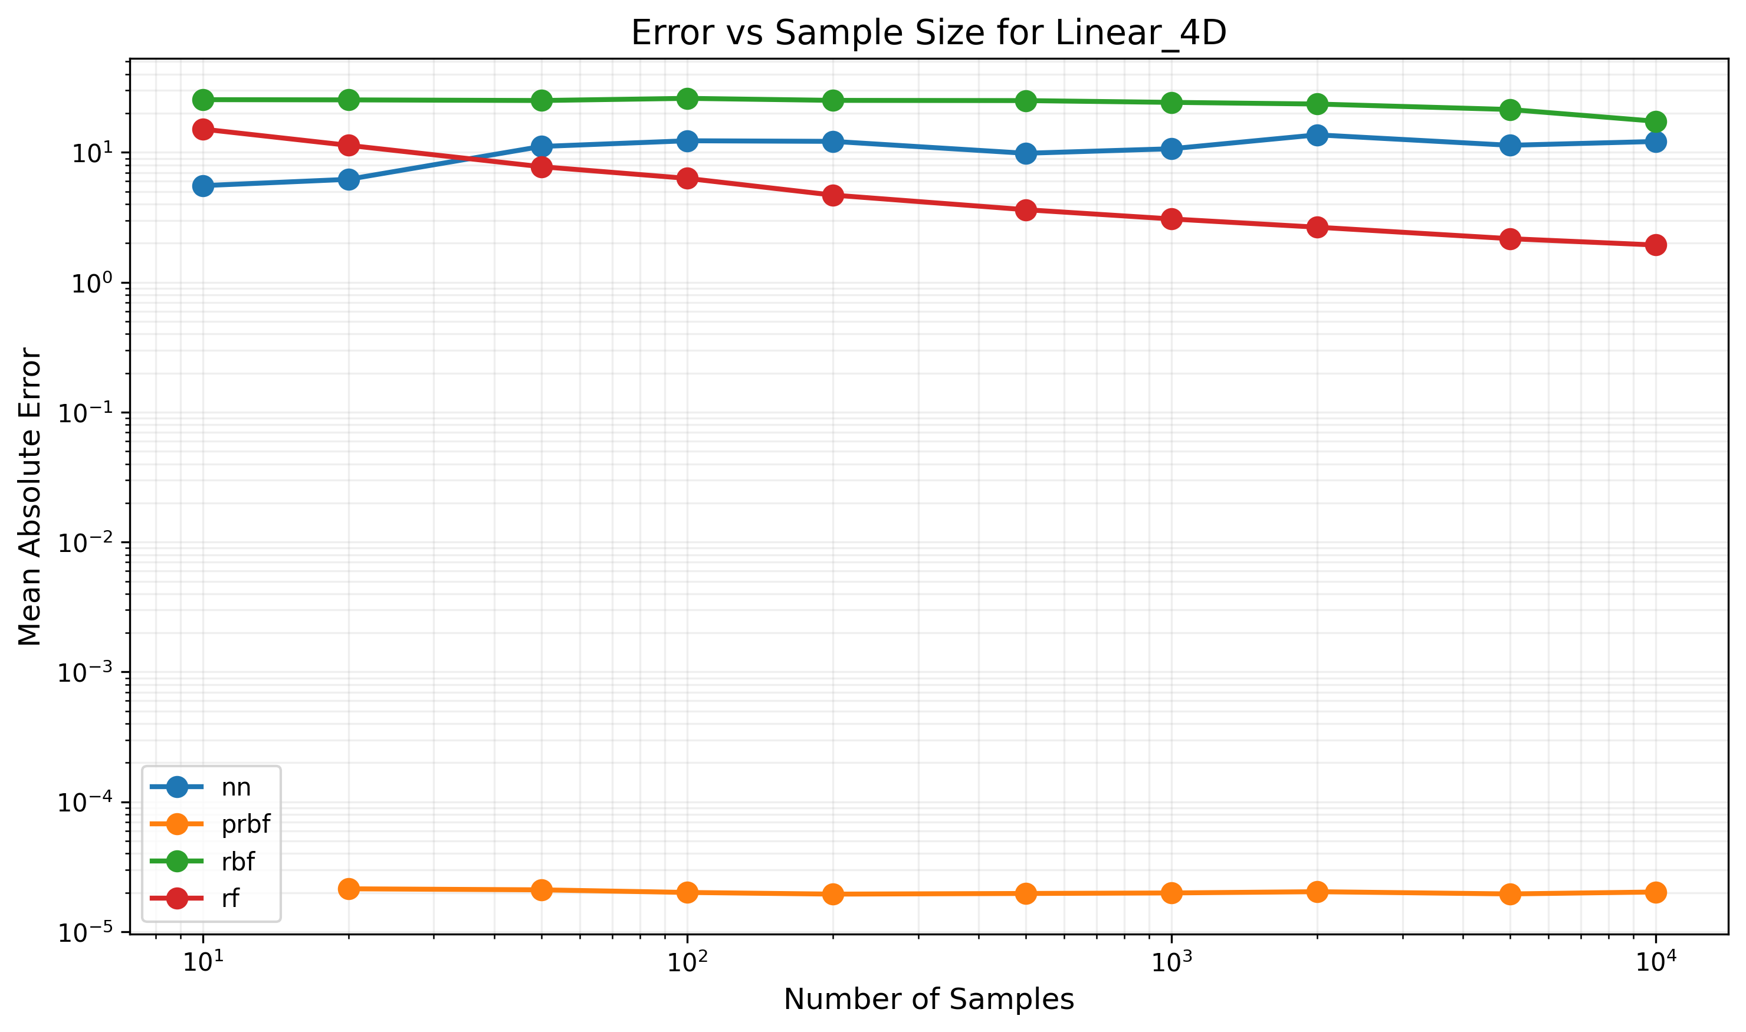

Figure: Error trends for Linear_4D function

## Function: Linear_5D

Dimensions: 5D -> 1D

Formula: x1 + 2x2 + 3x3 + 4x4 + 5x5 + 1

|  |  |  |  |  |  |  |  |  |  |  |
| --- | --- | --- | --- | --- | --- | --- | --- | --- | --- | --- |
| Model Type | 10 samples | 20 samples | 50 samples | 100 samples | 200 samples | 500 samples | 1000 samples | 2000 samples | 5000 samples | 10000 samples |
| nn | 2935.68% | 1035.49% | 1533.67% | 1377.55% | 1385.35% | 1442.21% | 1565.50% | 1452.41% | 1389.40% | 1493.40% |
| prbf | FAIL | FAIL | 0.00% | 0.00% | 0.00% | 0.00% | 0.00% | 0.00% | 0.00% | 0.00% |
| rbf | 3517.69% | 3505.32% | 3443.73% | 3514.57% | 3339.92% | 3463.65% | 3552.34% | 3353.96% | 3408.19% | 3263.77% |
| rf | 2434.05% | 2217.85% | 1683.67% | 1173.57% | 1006.10% | 715.89% | 546.38% | 554.99% | 432.95% | 457.59% |

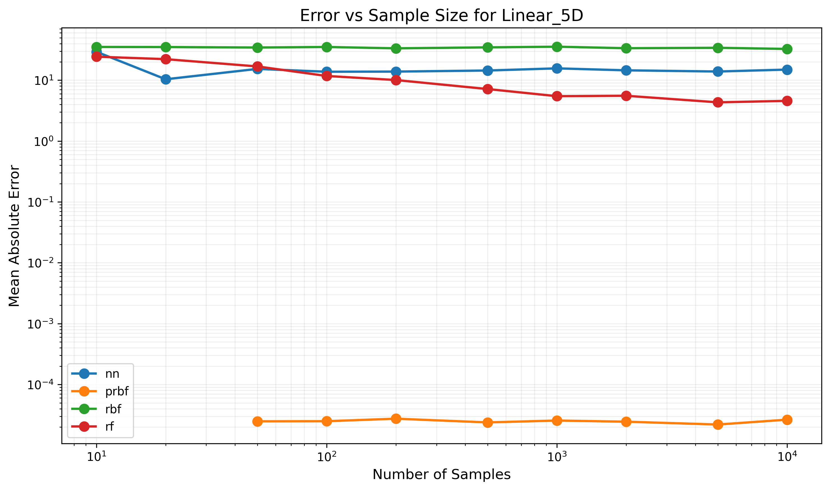

Figure: Error trends for Linear_5D function

## Function: Logarithmic

Dimensions: 3D -> 1D

Formula: log(abs(x)+11) + log(abs(y)+11) + log(abs(z)+11)

|  |  |  |  |  |  |  |  |  |  |  |
| --- | --- | --- | --- | --- | --- | --- | --- | --- | --- | --- |
| Model Type | 10 samples | 20 samples | 50 samples | 100 samples | 200 samples | 500 samples | 1000 samples | 2000 samples | 5000 samples | 10000 samples |
| nn | 47.03% | 22.08% | 19.96% | 11.31% | 23.80% | 27.51% | 25.06% | 25.58% | 26.06% | 34.23% |
| prbf | 656.84% | 30.62% | 15.56% | 10.32% | 8.42% | 6.57% | 5.36% | 2.79% | 0.78% | 0.36% |
| rbf | 824.26% | 820.26% | 811.64% | 789.52% | 744.01% | 622.03% | 460.47% | 212.87% | 23.55% | 10.63% |
| rf | 24.25% | 16.42% | 11.28% | 15.27% | 9.66% | 5.96% | 5.72% | 5.38% | 4.78% | 4.56% |

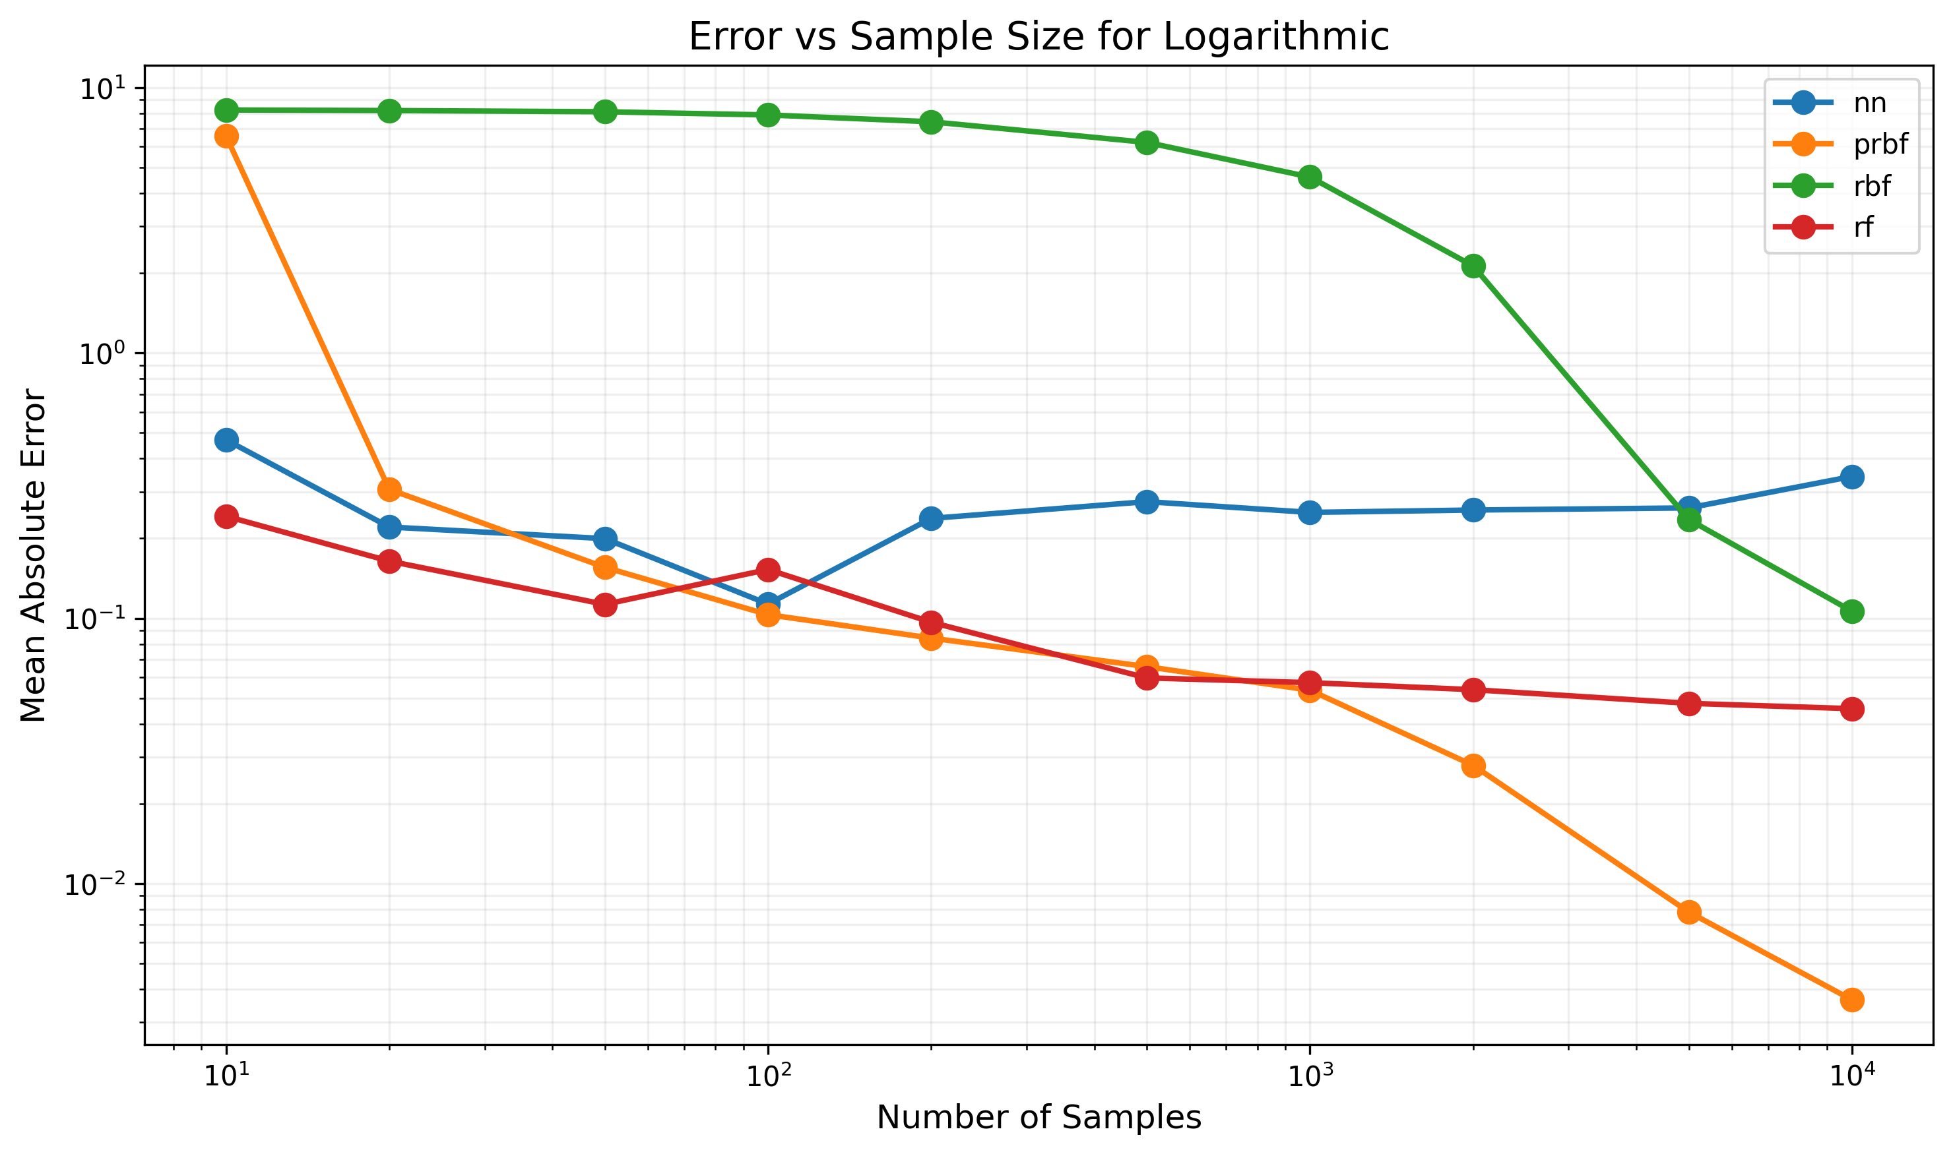

Figure: Error trends for Logarithmic function

## Function: Mixed_2D

Dimensions: 2D -> 1D

Formula: x*y + sin(x) + cos(y)

|  |  |  |  |  |  |  |  |
| --- | --- | --- | --- | --- | --- | --- | --- |
| Model Type | 10 samples | 20 samples | 50 samples | 100 samples | 200 samples | 500 samples | 1000 samples |
| nn | 4463.37% | 966.27% | 994.31% | 1330.98% | 1283.98% | 1196.10% | 1118.51% |
| prbf | 89.12% | 97.64% | 68.26% | 54.09% | 22.42% | 3.36% | 0.32% |
| rbf | 2390.69% | 2320.63% | 1827.09% | 1117.54% | 369.06% | 55.60% | 17.94% |
| rf | 2266.82% | 1156.77% | 652.67% | 462.47% | 212.30% | 134.93% | 565.50% |

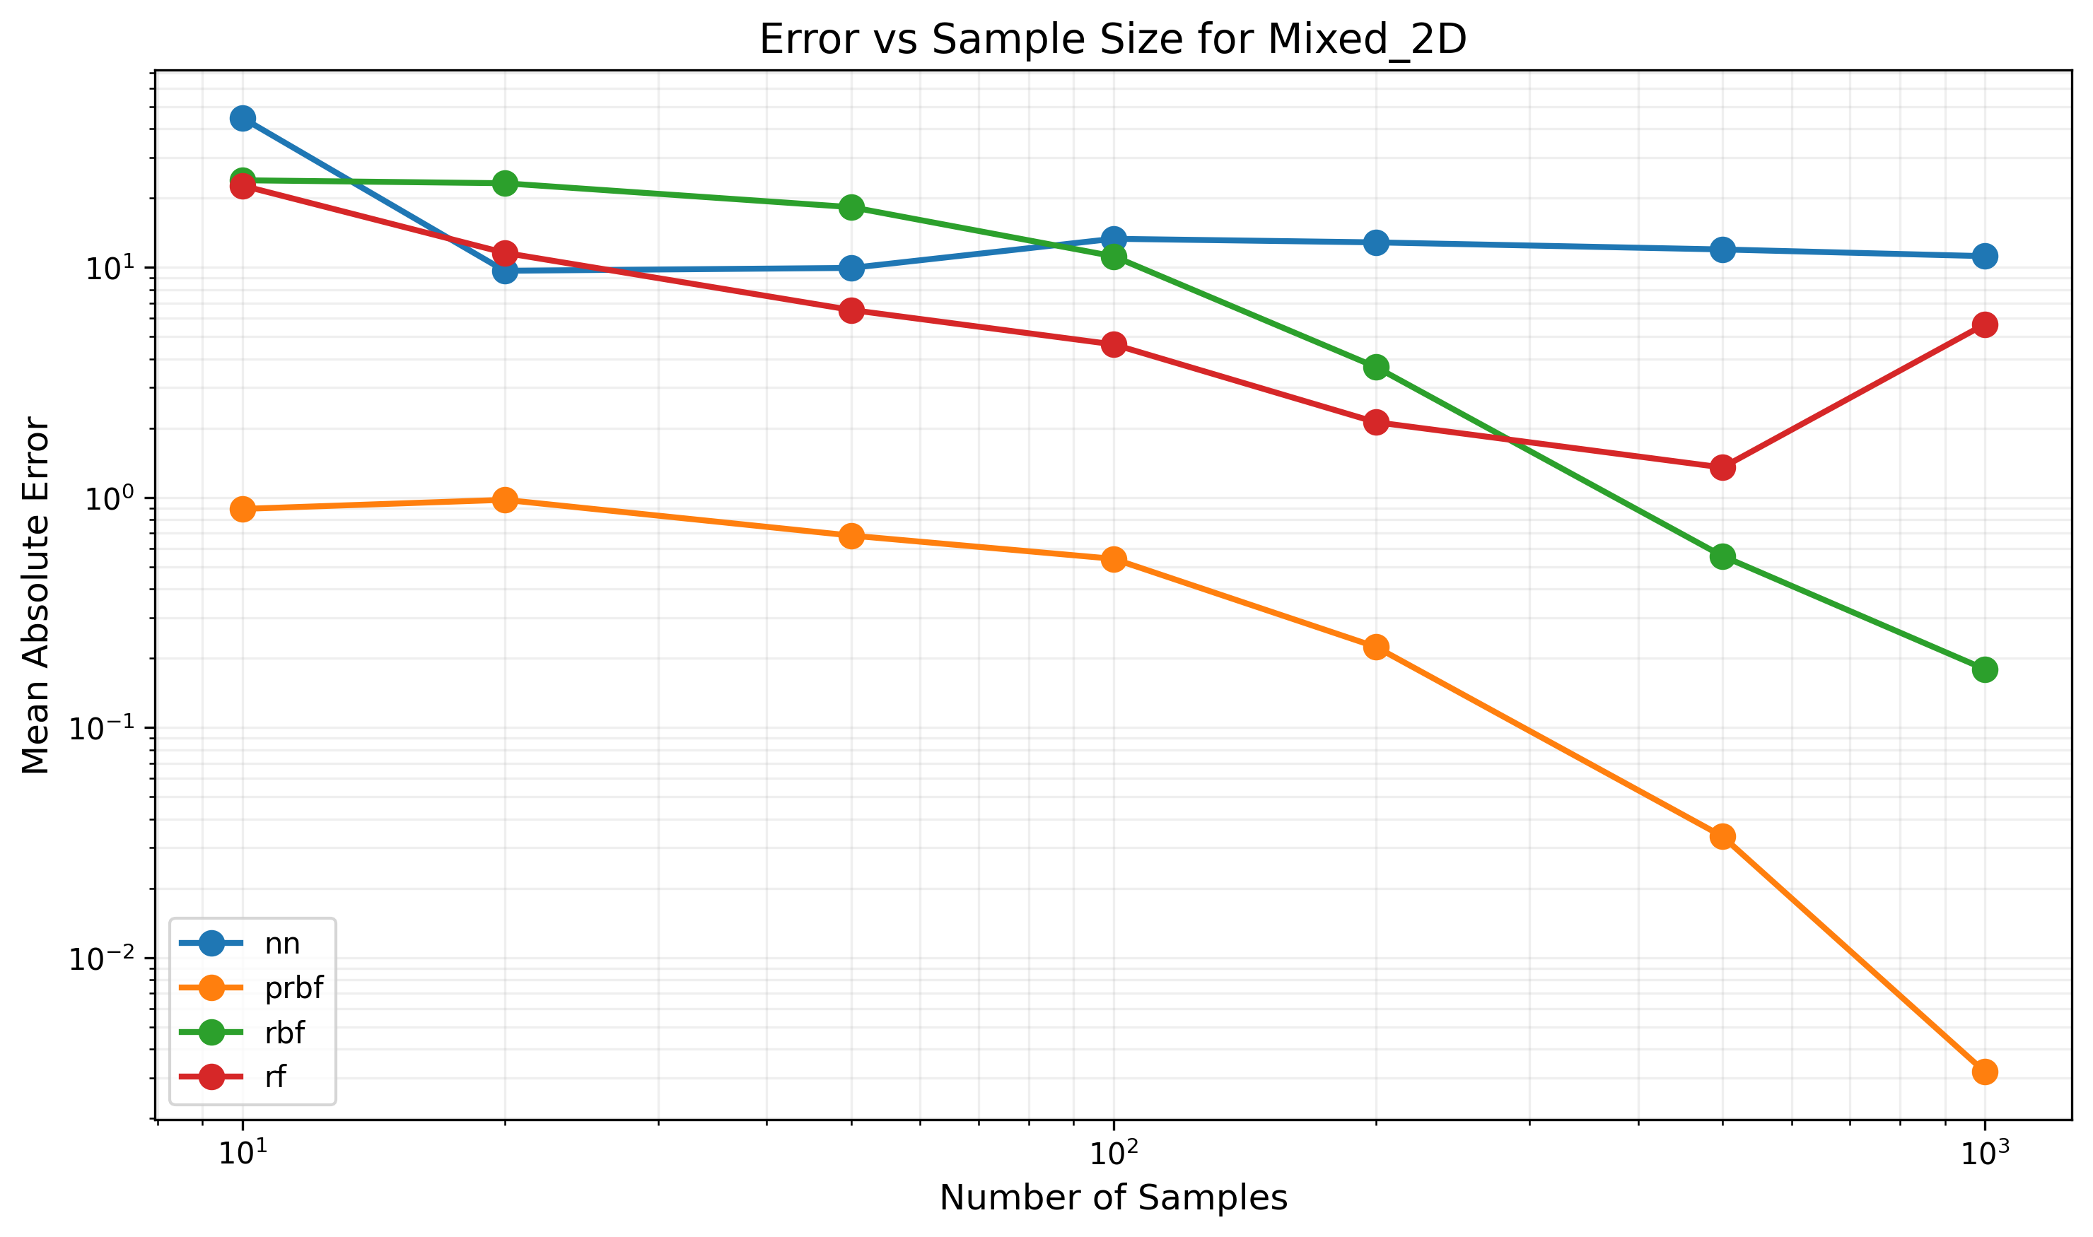

Figure: Error trends for Mixed_2D function

## Function: Mixed_3D_2out

Dimensions: 3D -> 2D

Formula: [sin(x) + cos(y), z^2 + x*y]

|  |  |  |  |  |  |  |  |  |  |  |
| --- | --- | --- | --- | --- | --- | --- | --- | --- | --- | --- |
| Model Type | 10 samples | 20 samples | 50 samples | 100 samples | 200 samples | 500 samples | 1000 samples | 2000 samples | 5000 samples | 10000 samples |
| nn | 3275.10% | 1166.11% | 1498.07% | 1275.68% | 890.38% | 844.10% | 818.25% | 934.28% | 812.51% | 861.95% |
| prbf | 180.41% | 45.97% | 46.34% | 45.79% | 36.77% | 32.38% | 26.59% | 14.96% | 3.05% | 0.73% |
| rbf | 2162.53% | 2212.68% | 2251.23% | 2238.85% | 2019.87% | 1722.38% | 1241.73% | 580.08% | 80.71% | 48.34% |
| rf | 1534.52% | 1346.69% | 1095.99% | 1007.78% | 761.08% | 538.25% | 490.45% | 398.99% | 451.18% | 415.97% |

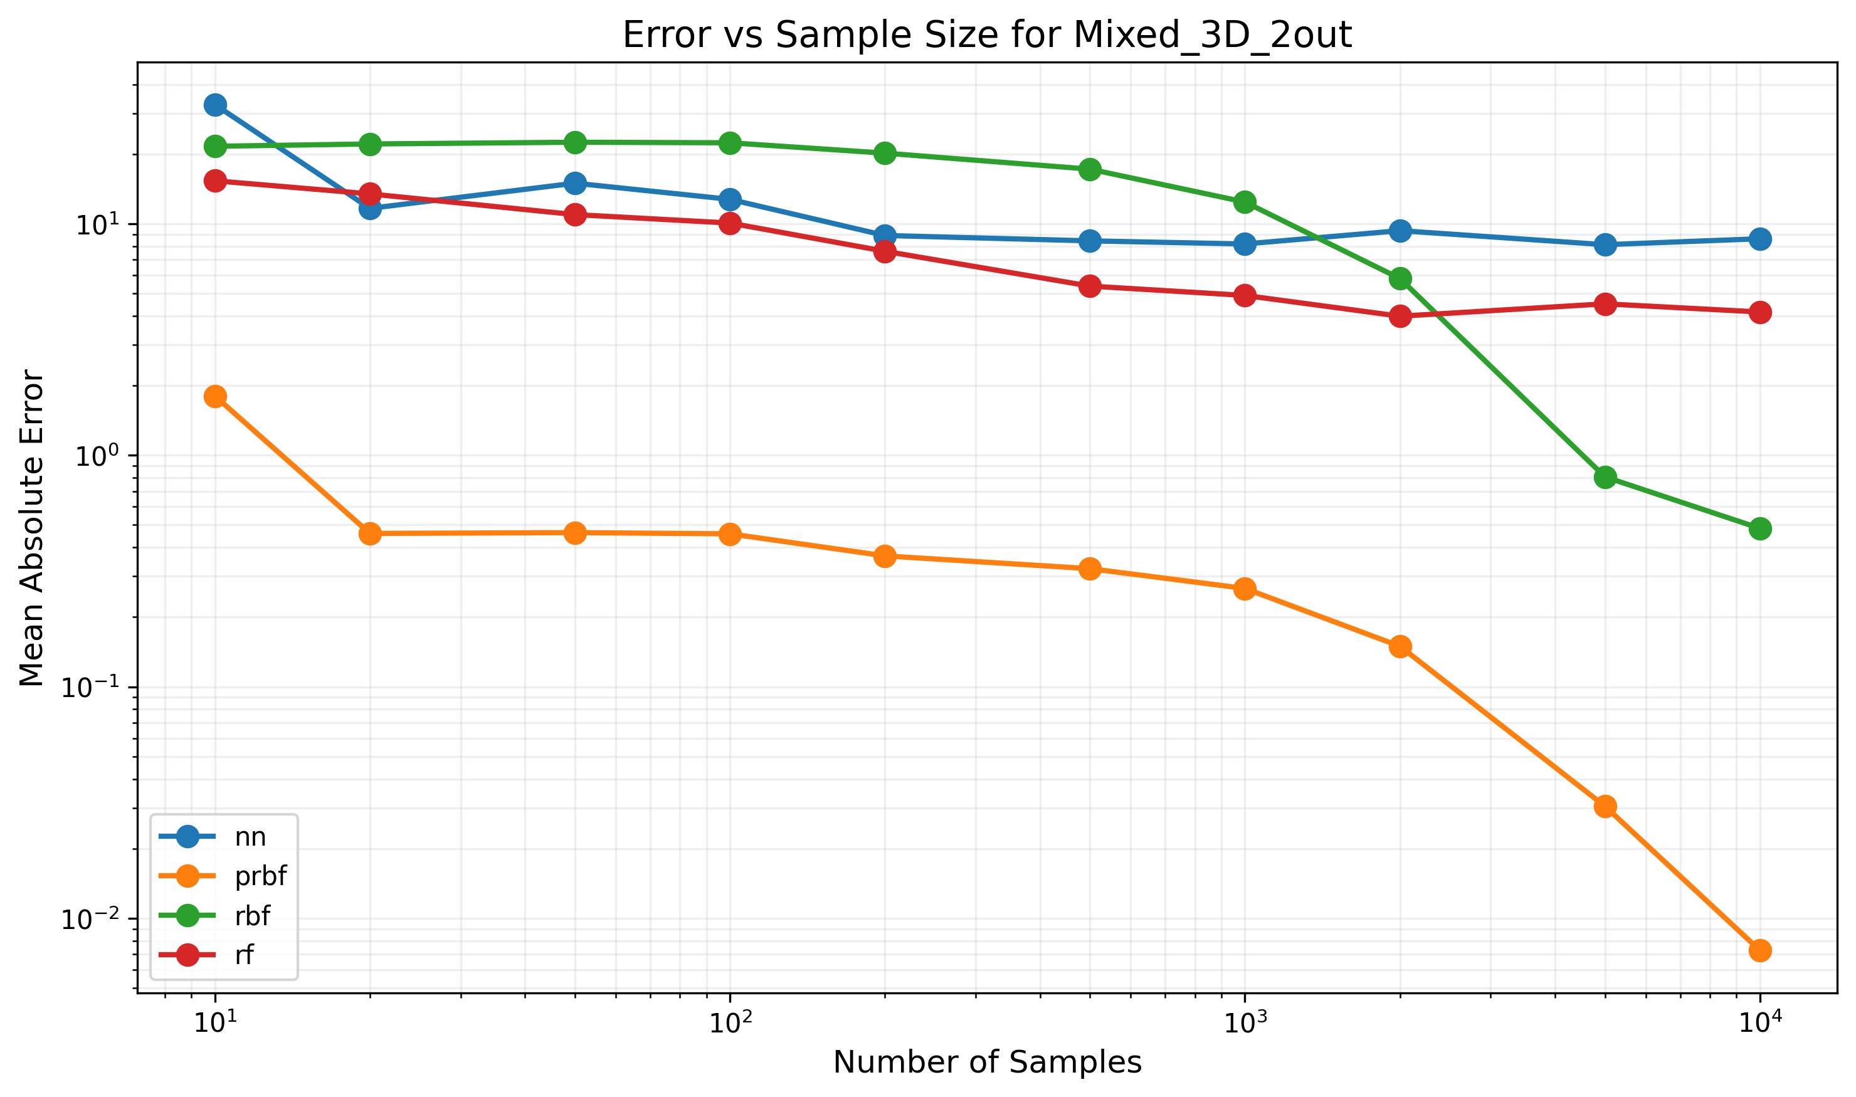

Figure: Error trends for Mixed_3D_2out function

## Function: Mixed_4D_2out

Dimensions: 4D -> 2D

Formula: [sin(x1) + cos(x2), exp(x3) + log(abs(x4)+1)]

|  |  |  |  |  |  |  |  |  |  |  |
| --- | --- | --- | --- | --- | --- | --- | --- | --- | --- | --- |
| Model Type | 10 samples | 20 samples | 50 samples | 100 samples | 200 samples | 500 samples | 1000 samples | 2000 samples | 5000 samples | 10000 samples |
| nn | 531670.05% | 280379.87% | 323823.53% | 346151.97% | 148745.37% | 100801.28% | 73503.32% | 39735.30% | 77655.20% | 128617.24% |
| prbf | FAIL | 313685.20% | 177013.08% | 200743.15% | 174724.36% | 130945.90% | 120203.07% | 129775.45% | 109099.32% | 79652.09% |
| rbf | 48494.65% | 51021.72% | 53015.18% | 60072.36% | 52540.12% | 48828.71% | 49111.85% | 44476.08% | 39305.34% | 30703.33% |
| rf | 170722.21% | 202878.81% | 34421.22% | 22796.79% | 12762.49% | 7140.85% | 3835.65% | 1053.58% | 744.45% | 232.13% |

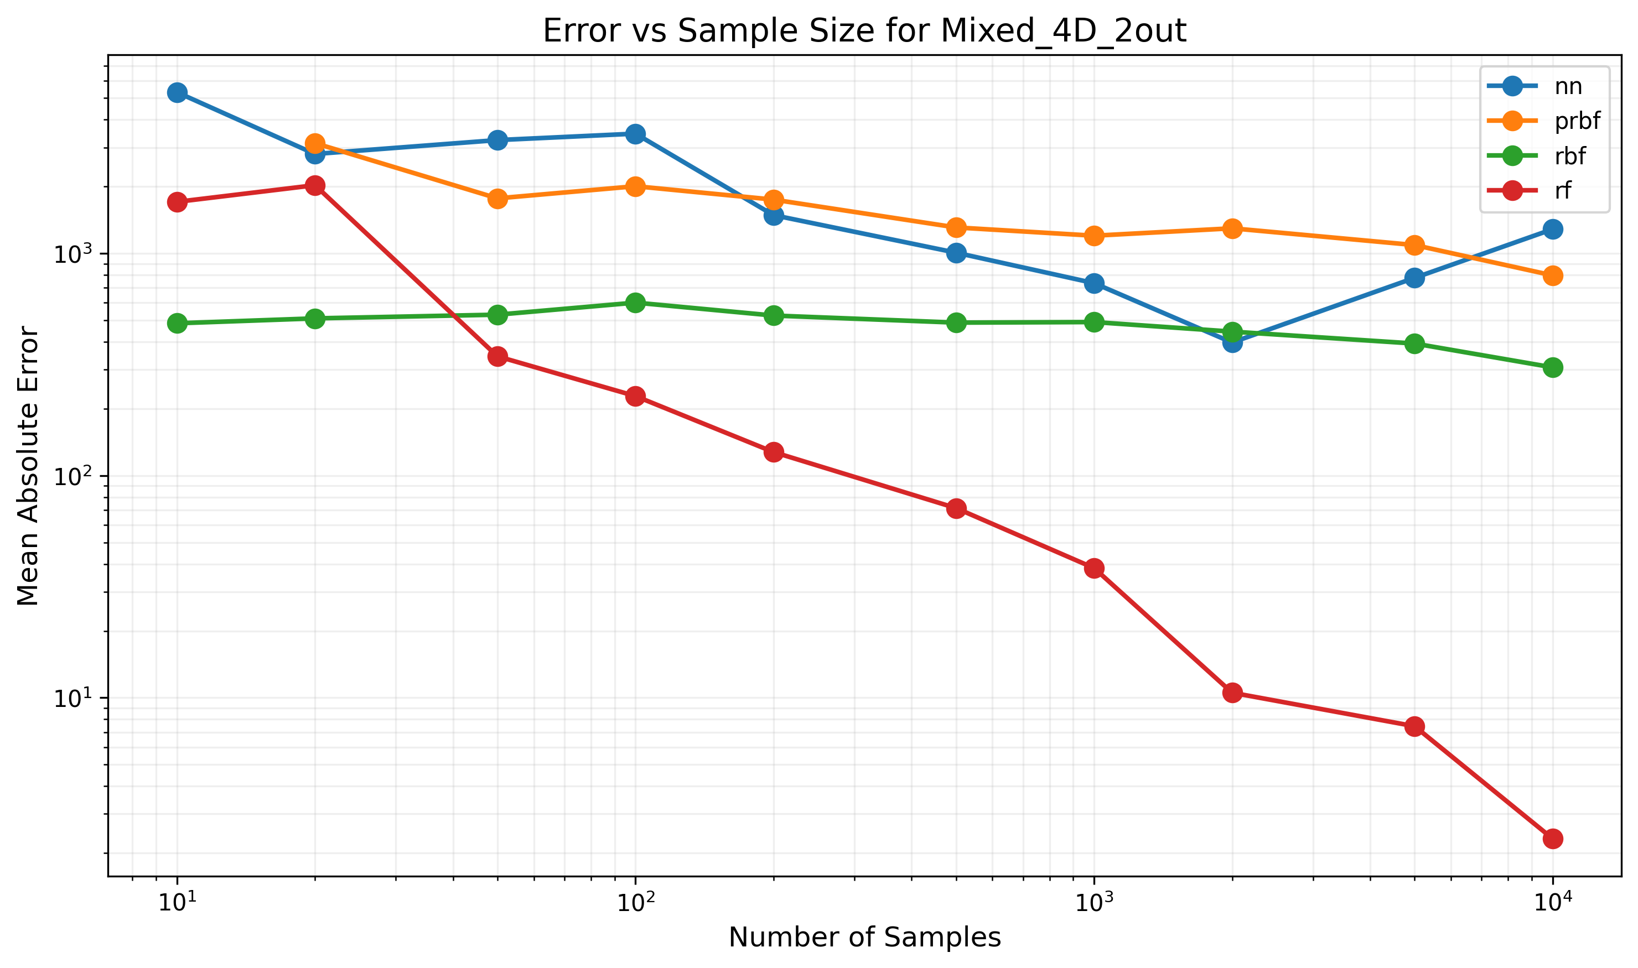

Figure: Error trends for Mixed_4D_2out function

## Function: Mixed_4D_3out

Dimensions: 4D -> 3D

Formula: [sin(x1), cos(x2), tanh(x3 + x4)]

|  |  |  |  |  |  |  |  |  |  |  |
| --- | --- | --- | --- | --- | --- | --- | --- | --- | --- | --- |
| Model Type | 10 samples | 20 samples | 50 samples | 100 samples | 200 samples | 500 samples | 1000 samples | 2000 samples | 5000 samples | 10000 samples |
| nn | 97.52% | 66.63% | 64.96% | 67.63% | 82.10% | 64.58% | 50.82% | 71.74% | 59.64% | 50.08% |
| prbf | FAIL | 64.82% | 62.95% | 61.00% | 62.06% | 55.82% | 54.62% | 52.66% | 47.06% | 39.04% |
| rbf | 74.00% | 73.26% | 73.77% | 73.27% | 72.43% | 72.48% | 69.90% | 68.67% | 61.24% | 52.25% |
| rf | 65.60% | 63.27% | 45.02% | 30.44% | 16.33% | 8.53% | 5.12% | 2.76% | 2.52% | 1.79% |

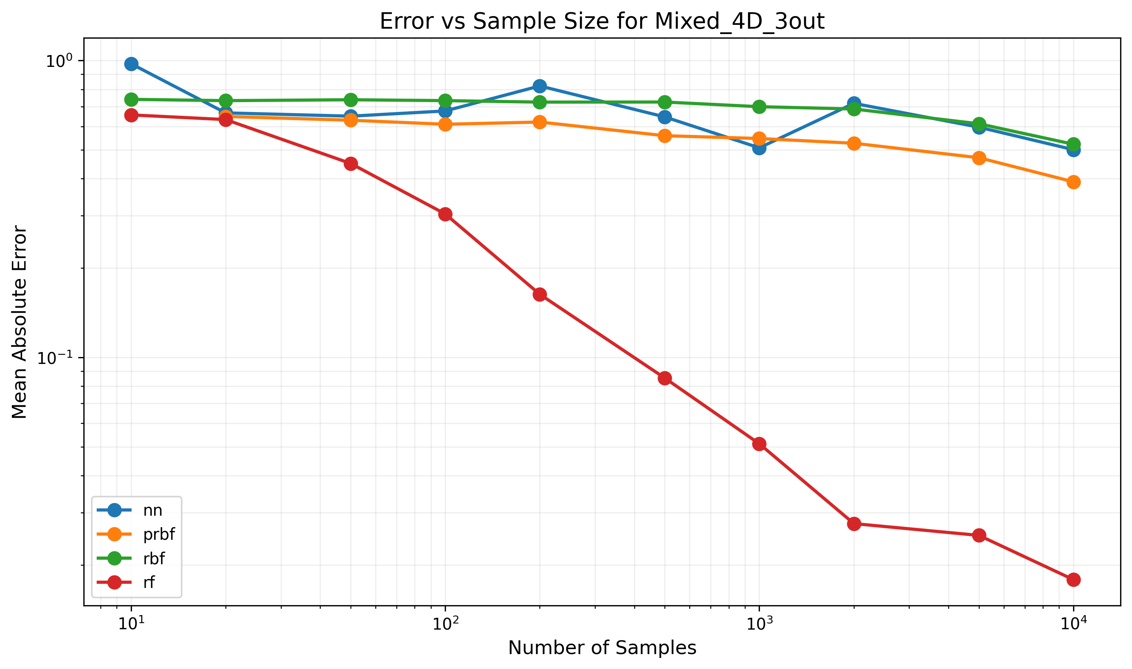

Figure: Error trends for Mixed_4D_3out function

## Function: Mixed_5D_2out

Dimensions: 5D -> 2D

Formula: [sin(x1) + cos(x2), exp(x3) + x4*x5]

|  |  |  |  |  |  |  |  |  |  |  |
| --- | --- | --- | --- | --- | --- | --- | --- | --- | --- | --- |
| Model Type | 10 samples | 20 samples | 50 samples | 100 samples | 200 samples | 500 samples | 1000 samples | 2000 samples | 5000 samples | 10000 samples |
| nn | 348632.29% | 298093.20% | 313143.36% | 332542.96% | 194503.92% | 134817.53% | 105120.92% | 66723.33% | 41383.07% | 89736.03% |
| prbf | FAIL | FAIL | 194963.85% | 201194.12% | 168190.16% | 167685.70% | 142681.91% | 153546.91% | 146607.58% | 149272.59% |
| rbf | 53376.25% | 55400.87% | 58213.52% | 56430.11% | 51797.44% | 55118.78% | 63714.06% | 55490.42% | 48279.67% | 42445.67% |
| rf | 120142.42% | 99709.16% | 43153.61% | 21434.23% | 8479.94% | 6824.42% | 3538.72% | 1484.96% | 1207.40% | 1217.83% |

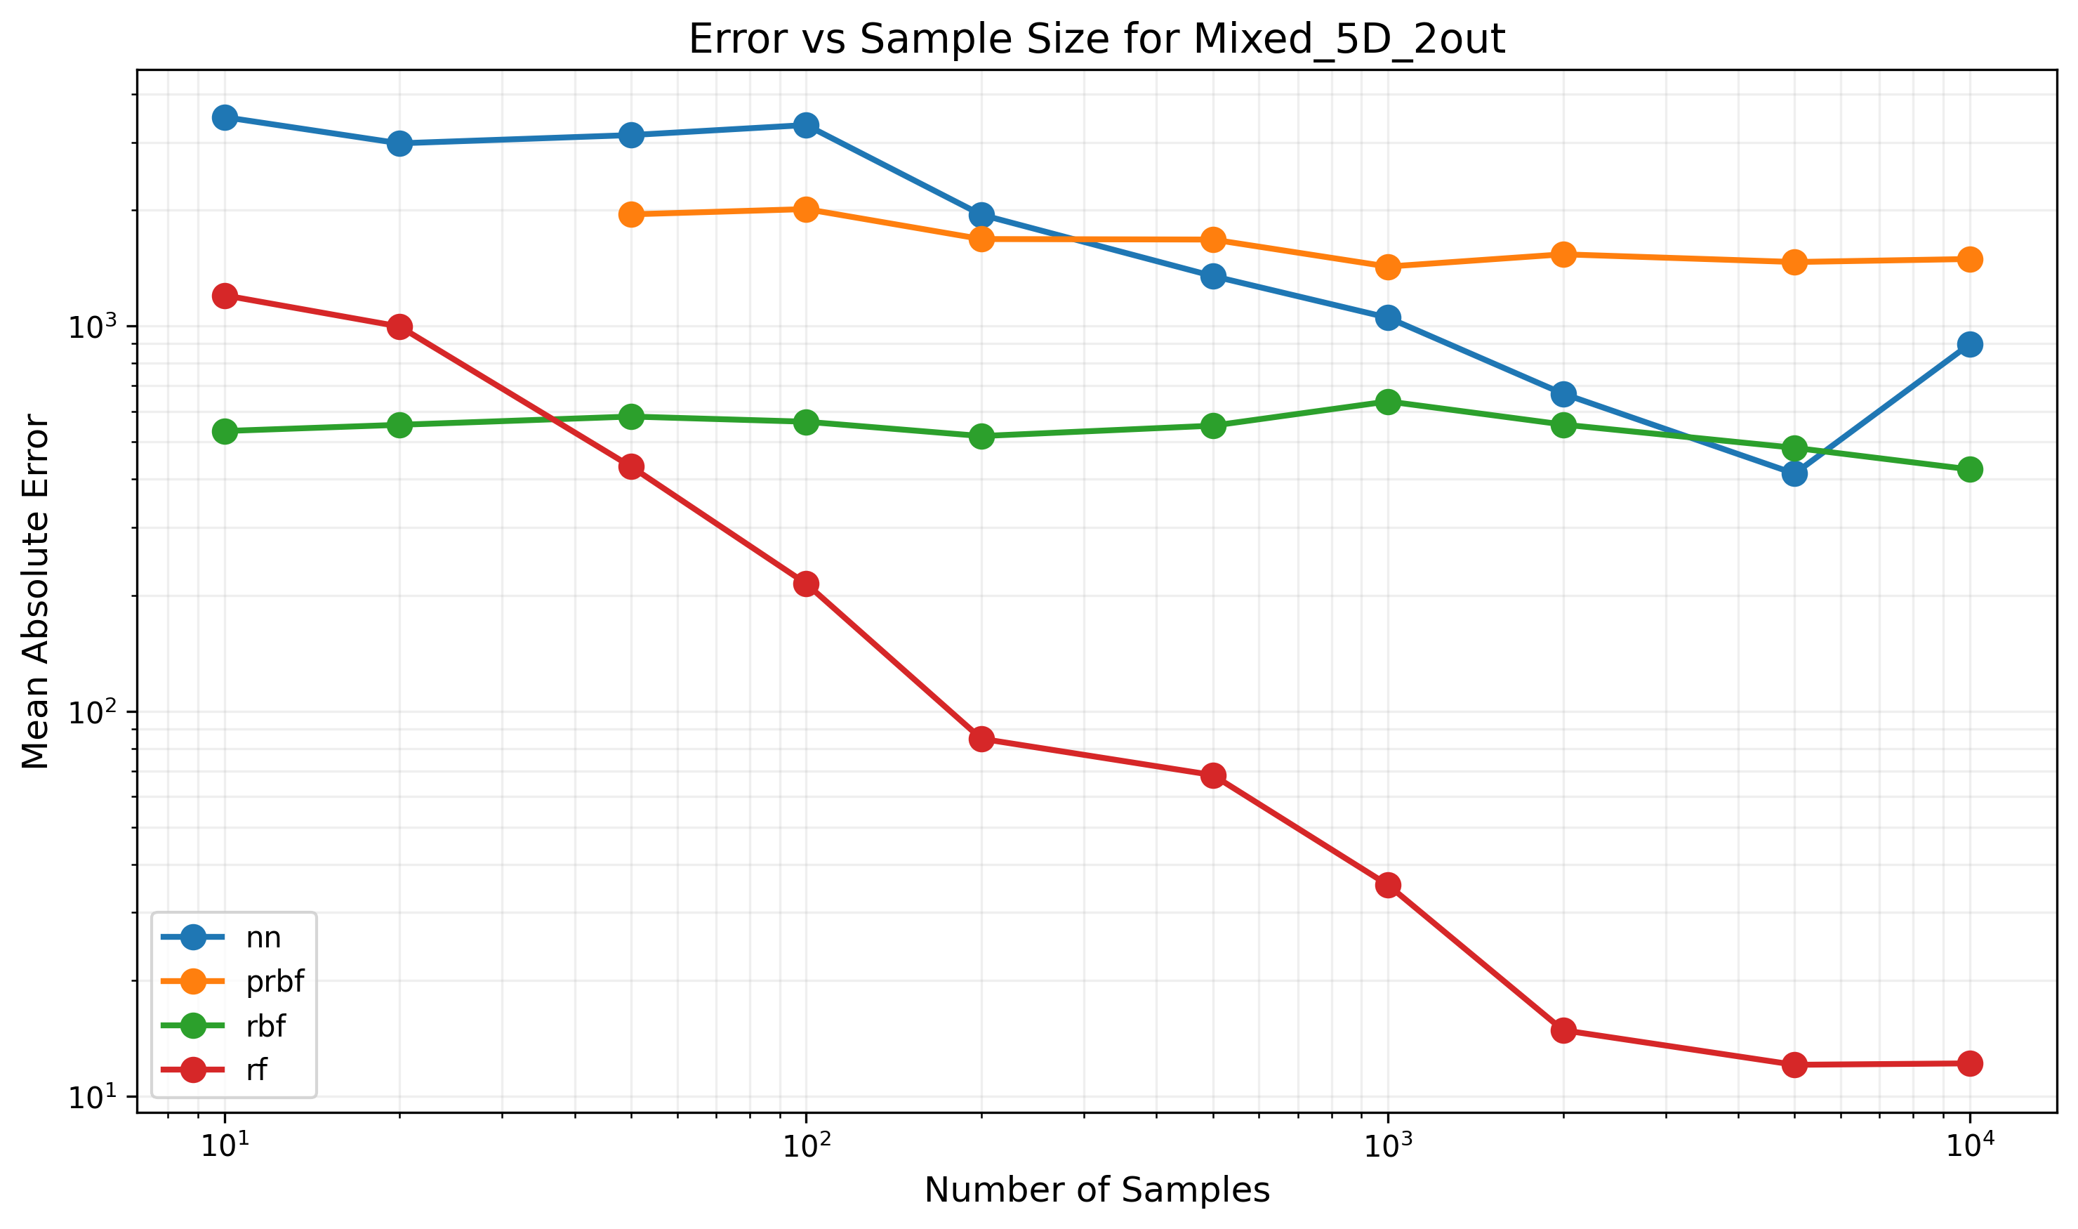

Figure: Error trends for Mixed_5D_2out function

## Function: Mixed_5D_3out

Dimensions: 5D -> 3D

Formula: [sin(x1+x2), cos(x3*x4), tanh(x5)]

|  |  |  |  |  |  |  |  |  |  |  |
| --- | --- | --- | --- | --- | --- | --- | --- | --- | --- | --- |
| Model Type | 10 samples | 20 samples | 50 samples | 100 samples | 200 samples | 500 samples | 1000 samples | 2000 samples | 5000 samples | 10000 samples |
| nn | 69.71% | 71.67% | 65.22% | 68.90% | 68.82% | 94.32% | 69.43% | 69.63% | 77.32% | 61.85% |
| prbf | FAIL | FAIL | 61.48% | 59.41% | 57.48% | 58.96% | 55.13% | 54.85% | 56.51% | 52.89% |
| rbf | 73.53% | 72.11% | 74.02% | 73.15% | 74.11% | 73.46% | 73.75% | 72.43% | 73.33% | 73.09% |
| rf | 62.49% | 56.03% | 48.13% | 48.46% | 45.45% | 44.19% | 44.05% | 40.74% | 38.84% | 34.94% |

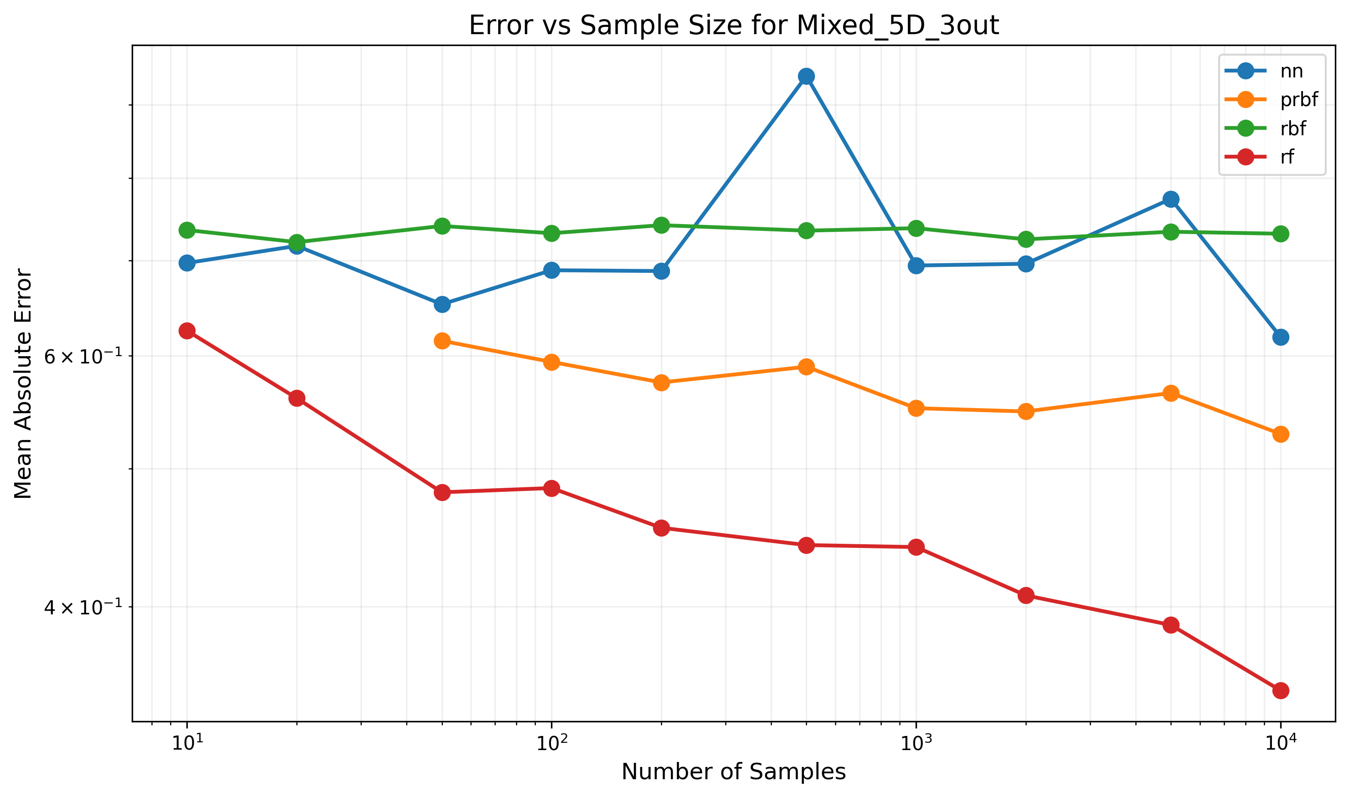

Figure: Error trends for Mixed_5D_3out function

## Function: Polynomial

Dimensions: 3D -> 1D

Formula: 1 + 0.5(x^2+y^2+z^2) + 0.1(x^3+y^3+z^3)

|  |  |  |  |  |  |  |  |  |  |  |
| --- | --- | --- | --- | --- | --- | --- | --- | --- | --- | --- |
| Model Type | 10 samples | 20 samples | 50 samples | 100 samples | 200 samples | 500 samples | 1000 samples | 2000 samples | 5000 samples | 10000 samples |
| nn | 10843.61% | 5651.52% | 4010.59% | 3445.38% | 3026.95% | 2910.12% | 3264.53% | 2509.68% | 2428.55% | 3078.42% |
| prbf | 3850.83% | 3258.86% | 3184.72% | 2909.89% | 2196.59% | 1711.35% | 1367.02% | 564.68% | 133.21% | 77.38% |
| rbf | 6663.73% | 6166.28% | 6061.76% | 5820.59% | 5599.88% | 4799.89% | 3410.83% | 1486.51% | 266.50% | 180.38% |
| rf | 2756.88% | 3929.96% | 1330.63% | 1335.02% | 1102.35% | 627.48% | 563.12% | 552.68% | 496.97% | 459.20% |

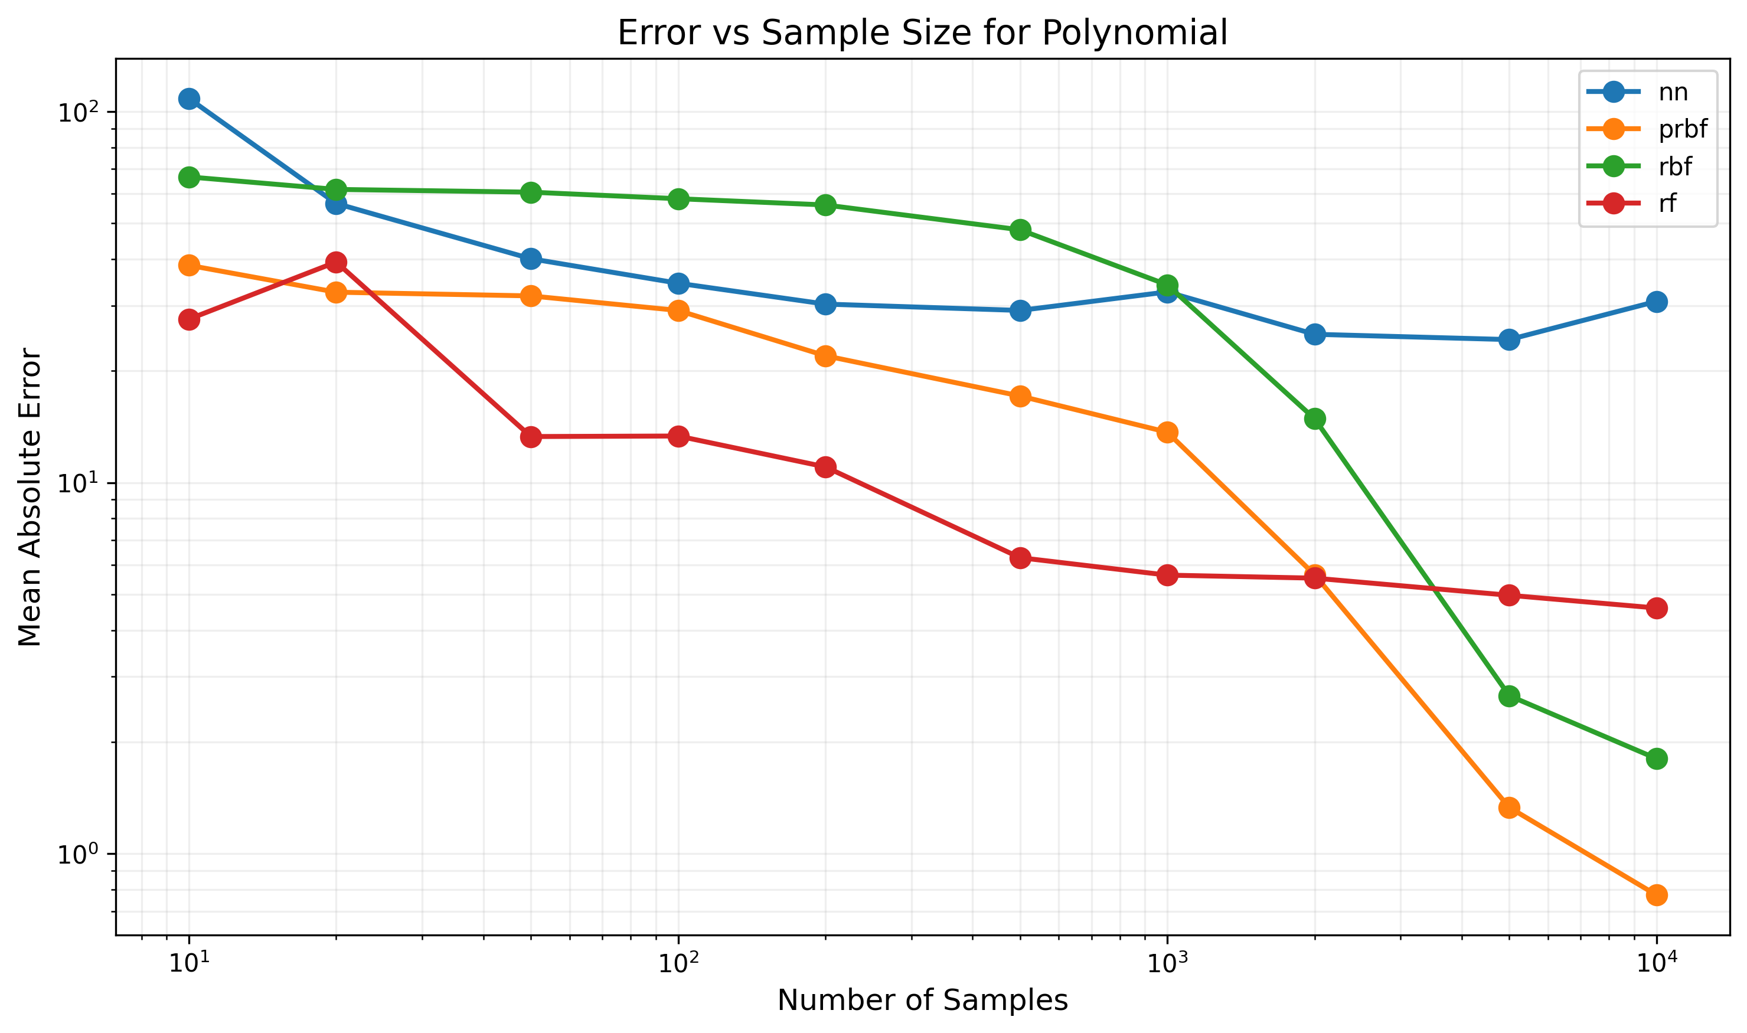

Figure: Error trends for Polynomial function

## Function: Product

Dimensions: 3D -> 1D

Formula: x * y * z

|  |  |  |  |  |  |  |  |  |  |  |
| --- | --- | --- | --- | --- | --- | --- | --- | --- | --- | --- |
| Model Type | 10 samples | 20 samples | 50 samples | 100 samples | 200 samples | 500 samples | 1000 samples | 2000 samples | 5000 samples | 10000 samples |
| nn | 36341.84% | 30043.57% | 8848.77% | 12562.08% | 7296.53% | 9195.09% | 6357.43% | 7195.13% | 6575.39% | 6213.76% |
| prbf | 77850.77% | 29255.15% | 12181.59% | 12047.44% | 12687.35% | 9871.43% | 7486.57% | 2792.61% | 470.04% | 362.02% |
| rbf | 11968.22% | 12981.49% | 12046.70% | 11945.43% | 11541.30% | 8819.28% | 7029.03% | 3122.02% | 502.75% | 294.36% |
| rf | 14391.55% | 14204.42% | 12351.71% | 8110.38% | 7721.55% | 6524.82% | 6191.87% | 4975.06% | 4409.48% | 5246.74% |

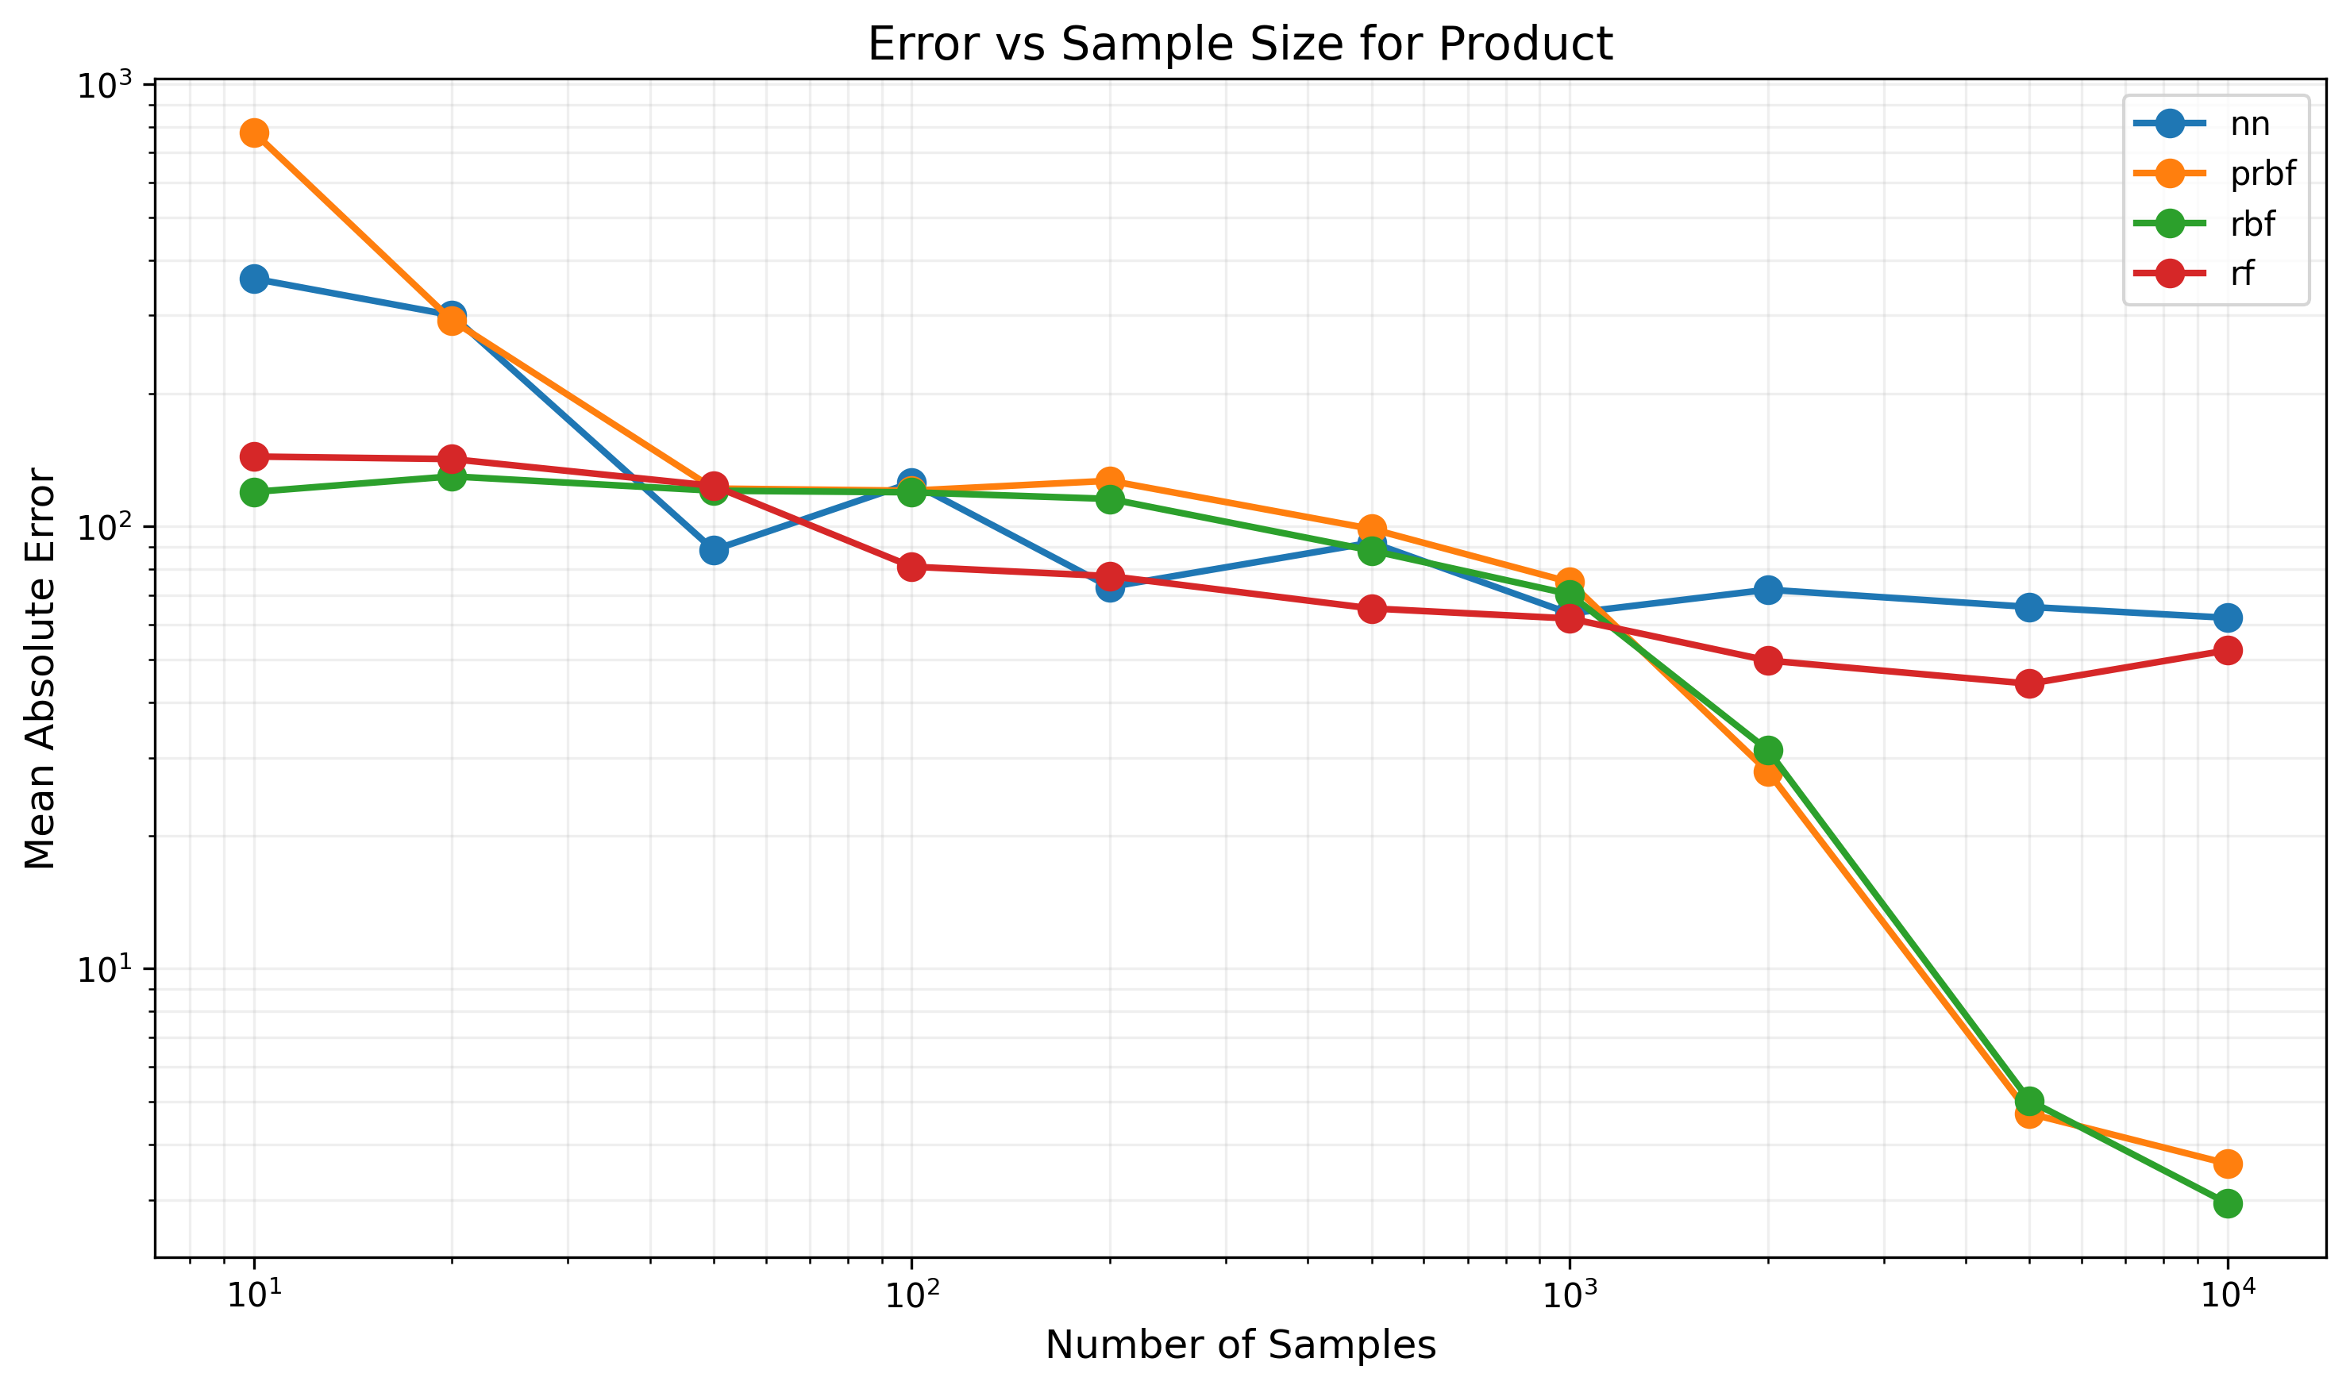

Figure: Error trends for Product function

## Function: Quadratic

Dimensions: 3D -> 1D

Formula: x^2 + y^2 + z^2

|  |  |  |  |  |  |  |  |  |  |  |
| --- | --- | --- | --- | --- | --- | --- | --- | --- | --- | --- |
| Model Type | 10 samples | 20 samples | 50 samples | 100 samples | 200 samples | 500 samples | 1000 samples | 2000 samples | 5000 samples | 10000 samples |
| nn | 9321.68% | 2789.56% | 2987.39% | 2123.21% | 2615.70% | 2240.14% | 2417.02% | 1972.66% | 1995.69% | 1867.01% |
| prbf | 0.02% | 0.01% | 0.01% | 0.02% | 0.01% | 0.01% | 0.01% | 0.02% | 0.02% | 0.02% |
| rbf | 10177.28% | 9903.09% | 9689.03% | 9655.83% | 8704.24% | 7605.25% | 5600.06% | 2481.56% | 321.08% | 238.66% |
| rf | 7076.82% | 3829.28% | 1702.35% | 1591.01% | 1242.14% | 1022.15% | 930.92% | 866.68% | 789.07% | 744.16% |

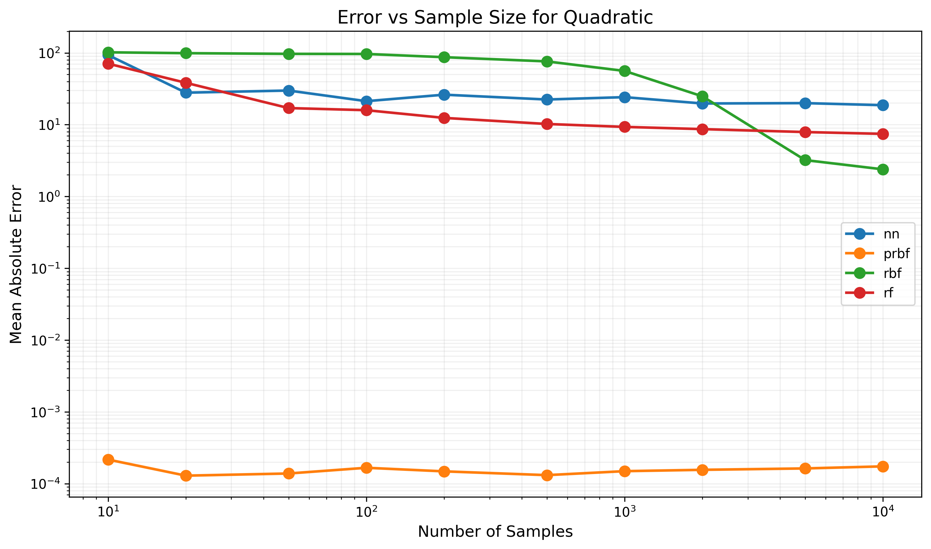

Figure: Error trends for Quadratic function

## Function: Quadratic_1D

Dimensions: 1D -> 1D

Formula: x^2 + 2x + 1

|  |  |  |  |  |  |  |  |  |  |  |
| --- | --- | --- | --- | --- | --- | --- | --- | --- | --- | --- |
| Model Type | 10 samples | 20 samples | 50 samples | 100 samples | 200 samples | 500 samples | 1000 samples | 2000 samples | 5000 samples | 10000 samples |
| nn | 1272.24% | 656.70% | 715.25% | 1200.01% | 1084.64% | 1117.14% | 1251.12% | 1344.83% | 1098.70% | 1187.88% |
| prbf | 0.00% | 0.00% | 0.00% | 0.00% | 0.00% | 0.00% | 0.00% | 0.00% | 0.00% | 0.00% |
| rbf | 633.96% | 88.89% | 3.28% | 1.51% | 1.09% | 0.61% | 0.44% | 0.35% | 0.25% | 0.19% |
| rf | 430.90% | 180.25% | 61.34% | 32.56% | 20.43% | 12.16% | 9.82% | 9.76% | 9.64% | 11.52% |

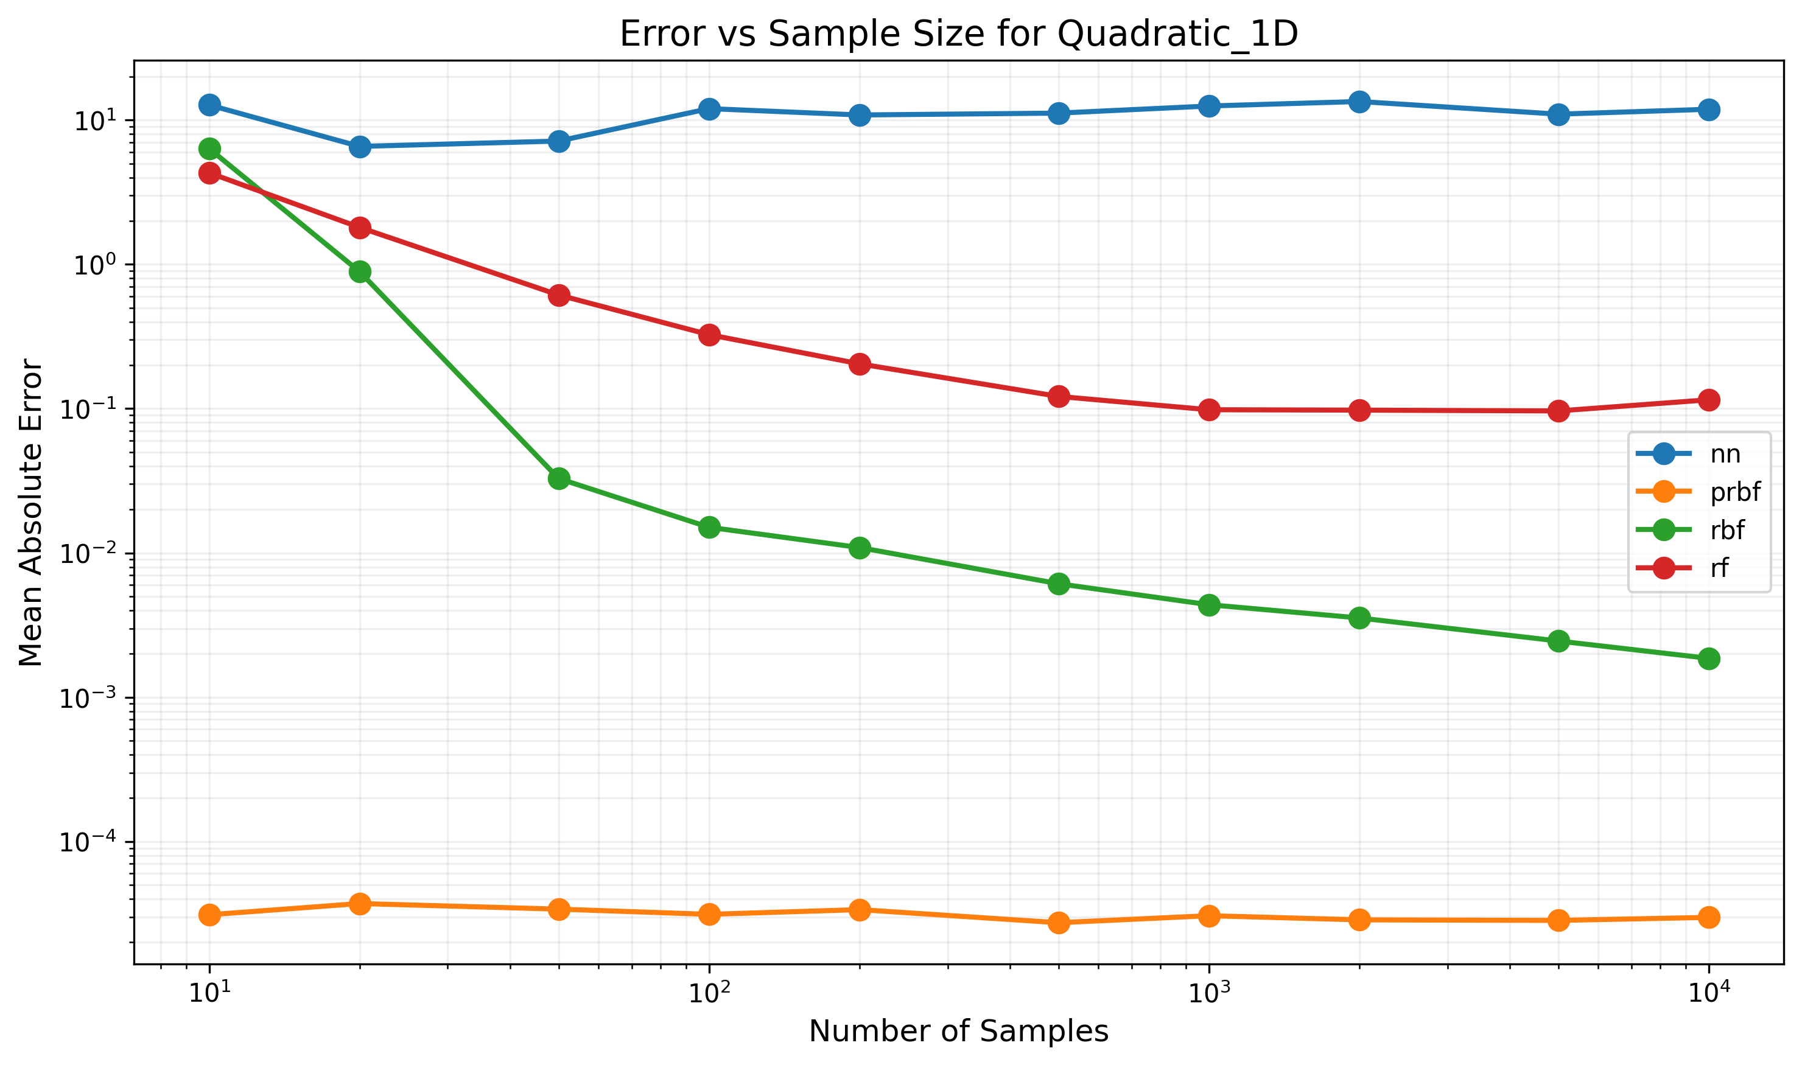

Figure: Error trends for Quadratic_1D function

## Function: Rastrigin

Dimensions: 3D -> 1D

Formula: 30 + (x^2-10cos(6.28x)) + (y^2-10cos(6.28y)) + (z^2-10cos(6.28z))

|  |  |  |  |  |  |  |  |  |  |  |
| --- | --- | --- | --- | --- | --- | --- | --- | --- | --- | --- |
| Model Type | 10 samples | 20 samples | 50 samples | 100 samples | 200 samples | 500 samples | 1000 samples | 2000 samples | 5000 samples | 10000 samples |
| nn | 6977.08% | 4368.76% | 1941.63% | 2511.90% | 1823.91% | 2537.70% | 3365.16% | 3879.58% | 3033.65% | 1133.56% |
| prbf | 5935.03% | 1998.64% | 1606.78% | 1145.58% | 1208.90% | 2336.12% | 1121.56% | 1180.96% | 1322.49% | 1542.95% |
| rbf | 13195.55% | 12767.12% | 12686.60% | 12181.29% | 11857.82% | 10388.29% | 7152.91% | 3498.43% | 1365.69% | 1410.02% |
| rf | 3141.53% | 3269.52% | 1794.62% | 1970.07% | 1976.74% | 1899.86% | 1368.83% | 1058.08% | 1207.16% | 1405.24% |

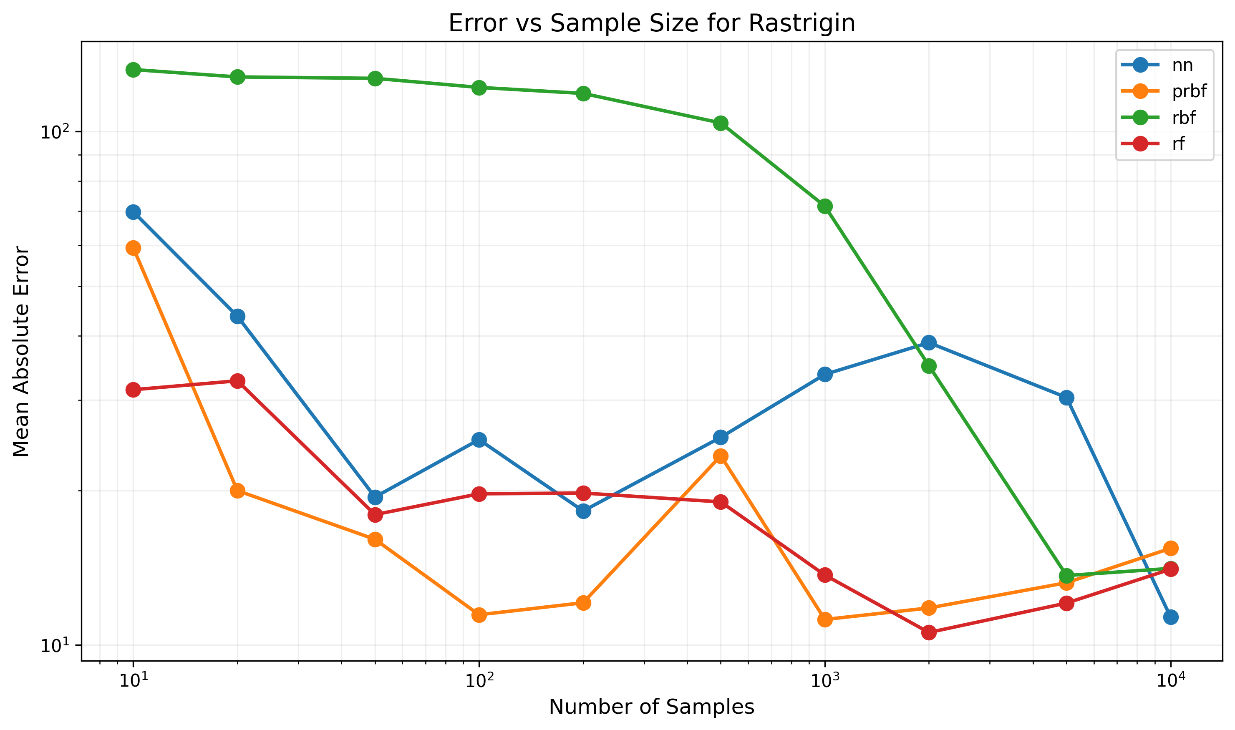

Figure: Error trends for Rastrigin function

## Function: Sin_1D

Dimensions: 1D -> 1D

Formula: sin(6.28x)

|  |  |  |  |  |  |  |  |  |  |  |
| --- | --- | --- | --- | --- | --- | --- | --- | --- | --- | --- |
| Model Type | 10 samples | 20 samples | 50 samples | 100 samples | 200 samples | 500 samples | 1000 samples | 2000 samples | 5000 samples | 10000 samples |
| nn | 63.10% | 82.92% | 64.79% | 62.58% | 63.15% | 65.19% | 63.54% | 63.33% | 63.00% | 63.52% |
| prbf | 75.00% | 80.89% | 32.66% | 23.92% | 15.77% | 8.21% | 4.48% | 2.61% | 1.14% | 0.60% |
| rbf | 74.32% | 79.44% | 33.72% | 24.16% | 16.13% | 8.07% | 4.62% | 2.60% | 1.14% | 0.58% |
| rf | 65.63% | 78.28% | 45.92% | 33.30% | 33.88% | 44.34% | 47.18% | 49.11% | 48.35% | 46.30% |

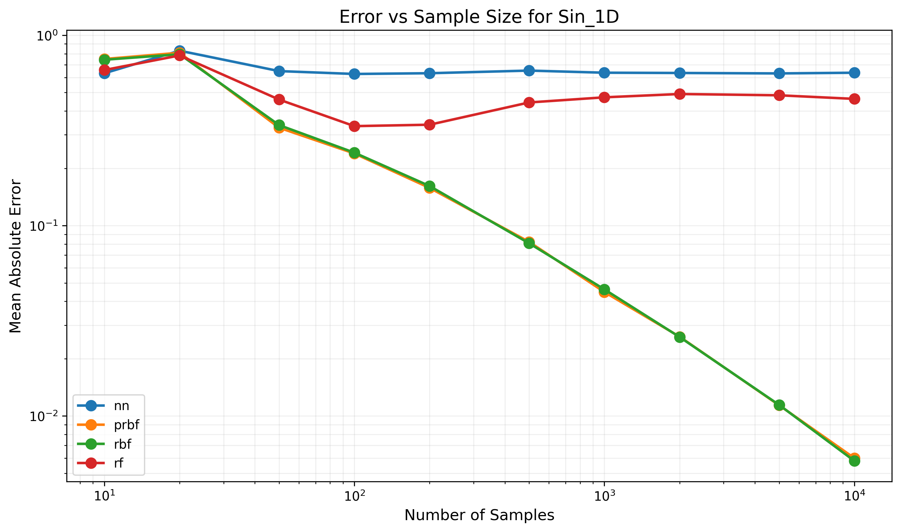

Figure: Error trends for Sin_1D function

## Function: Sinusoidal

Dimensions: 3D -> 1D

Formula: sin(x) + sin(y) + sin(z)

|  |  |  |  |  |  |  |  |  |  |  |
| --- | --- | --- | --- | --- | --- | --- | --- | --- | --- | --- |
| Model Type | 10 samples | 20 samples | 50 samples | 100 samples | 200 samples | 500 samples | 1000 samples | 2000 samples | 5000 samples | 10000 samples |
| nn | 114.17% | 119.71% | 117.16% | 122.82% | 128.22% | 97.21% | 97.78% | 96.22% | 97.52% | 96.32% |
| prbf | 715.29% | 124.25% | 101.44% | 106.21% | 91.39% | 78.22% | 63.39% | 34.79% | 7.18% | 2.11% |
| rbf | 99.44% | 102.95% | 93.86% | 95.98% | 84.27% | 76.62% | 61.07% | 37.29% | 7.21% | 1.74% |
| rf | 126.48% | 110.13% | 89.39% | 100.46% | 63.56% | 55.87% | 49.27% | 49.65% | 38.95% | 37.55% |

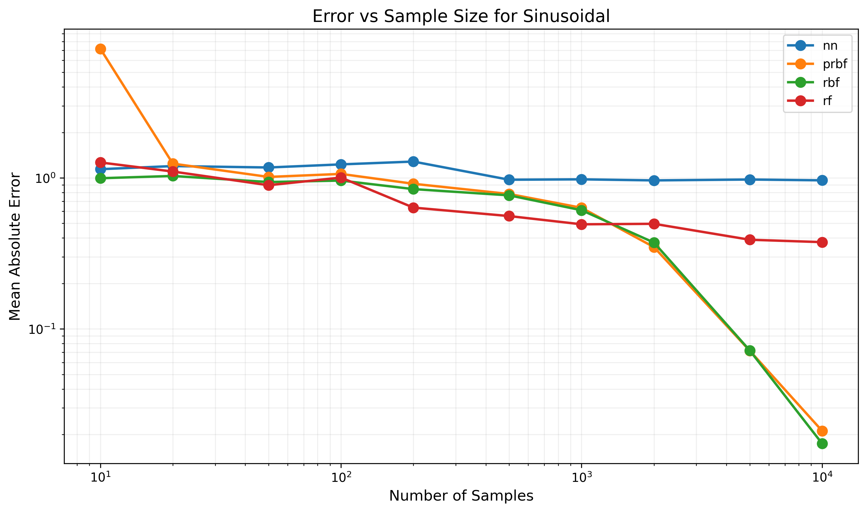

Figure: Error trends for Sinusoidal function

## Function: Trigonometric

Dimensions: 3D -> 1D

Formula: sin(x)cos(2x) + sin(y)cos(2y) + sin(z)cos(2z)

|  |  |  |  |  |  |  |  |  |  |  |
| --- | --- | --- | --- | --- | --- | --- | --- | --- | --- | --- |
| Model Type | 10 samples | 20 samples | 50 samples | 100 samples | 200 samples | 500 samples | 1000 samples | 2000 samples | 5000 samples | 10000 samples |
| nn | 65.66% | 68.25% | 68.88% | 69.36% | 77.85% | 91.25% | 65.33% | 88.08% | 71.16% | 69.07% |
| prbf | 101.84% | 67.72% | 68.21% | 66.43% | 65.64% | 71.41% | 65.38% | 54.49% | 43.38% | 6.06% |
| rbf | 69.07% | 67.95% | 68.82% | 65.37% | 65.80% | 61.93% | 64.87% | 53.46% | 45.33% | 5.39% |
| rf | 91.29% | 69.79% | 68.34% | 64.97% | 58.99% | 60.27% | 51.09% | 47.27% | 42.72% | 35.77% |

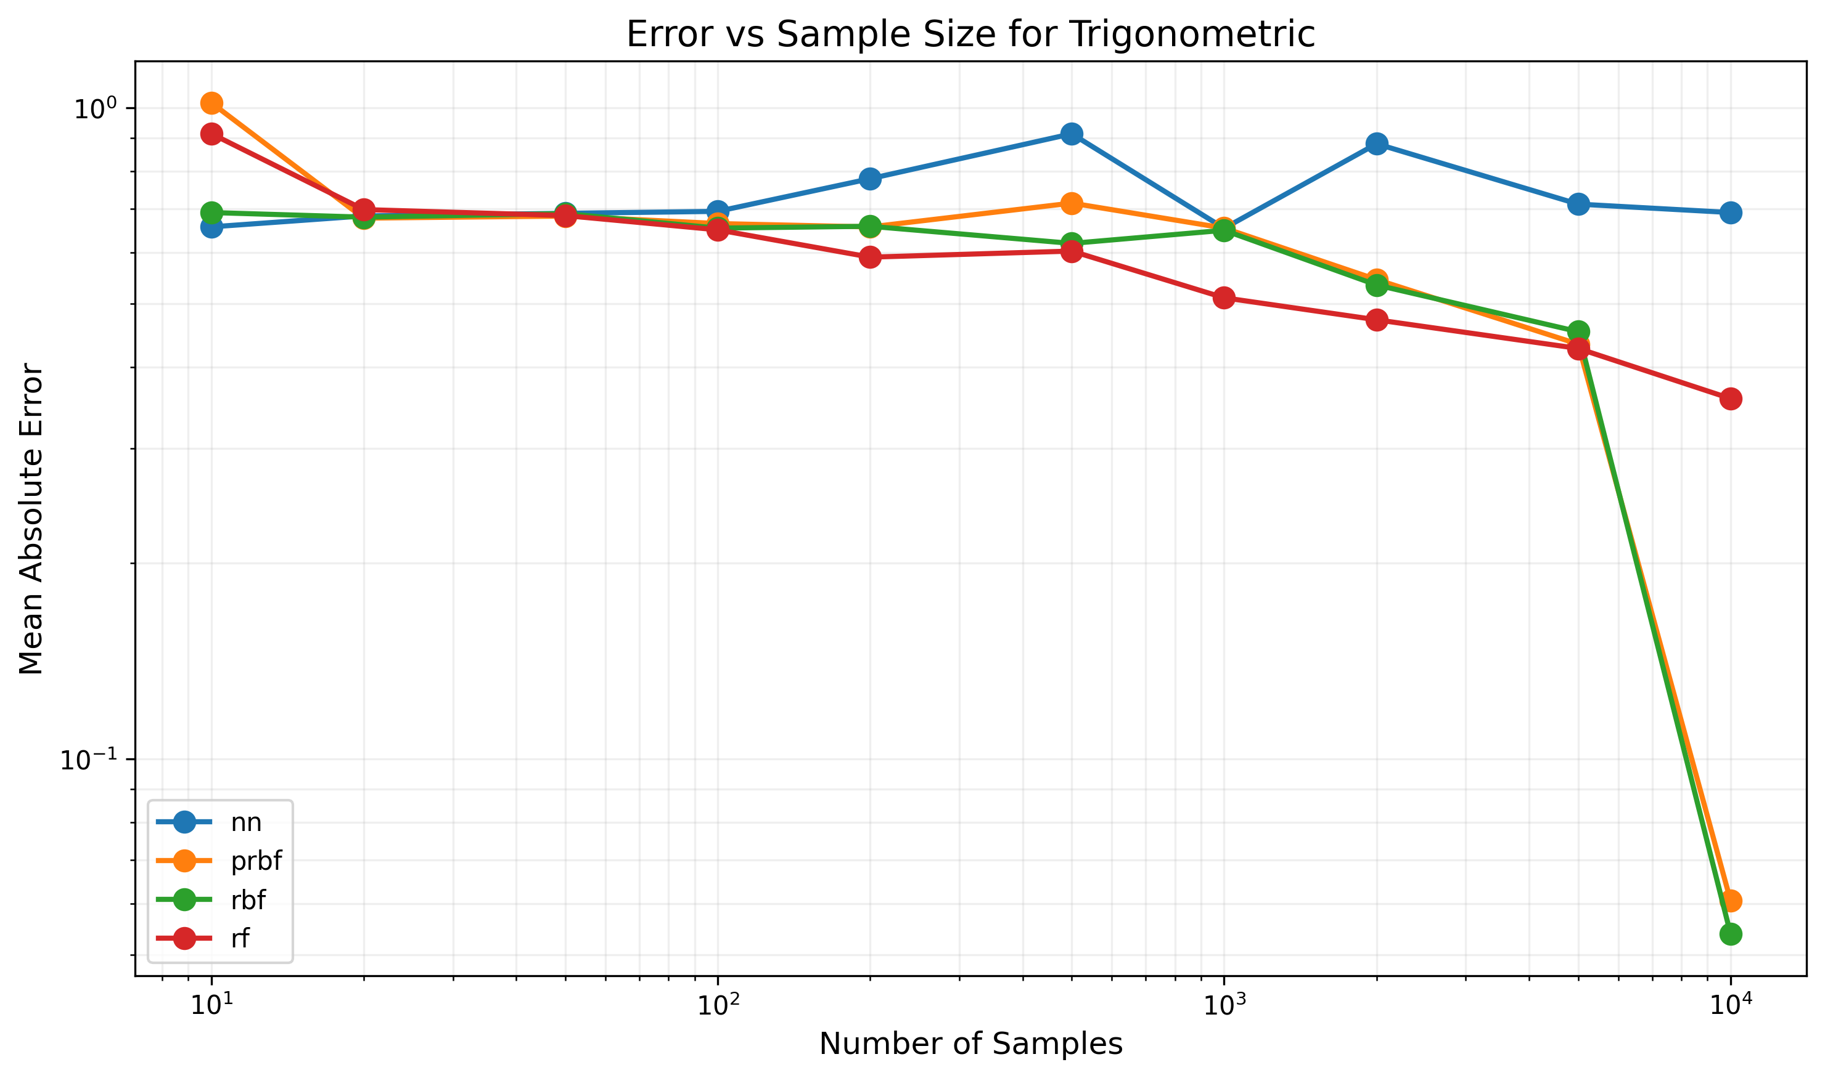

Figure: Error trends for Trigonometric function

## Function: Vector_3D_2out

Dimensions: 3D -> 2D

Formula: [x + y, y * z]

|  |  |  |  |  |  |  |  |  |  |  |
| --- | --- | --- | --- | --- | --- | --- | --- | --- | --- | --- |
| Model Type | 10 samples | 20 samples | 50 samples | 100 samples | 200 samples | 500 samples | 1000 samples | 2000 samples | 5000 samples | 10000 samples |
| nn | 1459.86% | 752.16% | 715.07% | 900.86% | 830.83% | 712.85% | 835.41% | 731.20% | 743.94% | 702.95% |
| prbf | 0.03% | 0.00% | 0.00% | 0.00% | 0.00% | 0.00% | 0.00% | 0.00% | 0.00% | 0.00% |
| rbf | 1616.57% | 1625.05% | 1559.53% | 1497.90% | 1430.39% | 1207.03% | 883.99% | 406.47% | 55.61% | 29.56% |
| rf | 1726.09% | 993.75% | 762.68% | 422.87% | 223.38% | 129.92% | 88.42% | 74.13% | 52.48% | 36.55% |

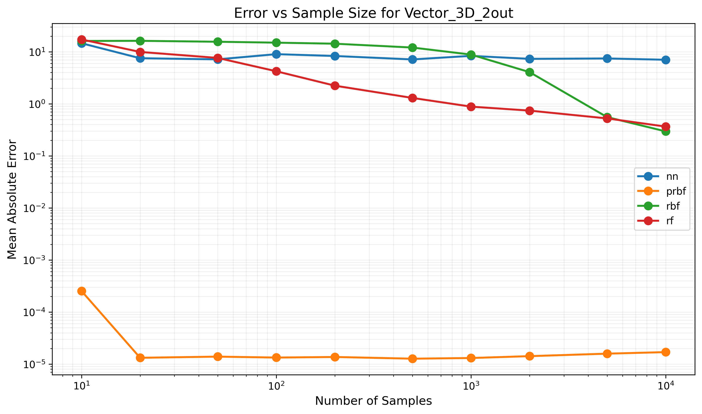

Figure: Error trends for Vector_3D_2out function

## Function: Vector_4D_2out

Dimensions: 4D -> 2D

Formula: [x1 + x2 + x3, x2 * x3 * x4]

|  |  |  |  |  |  |  |  |  |  |  |
| --- | --- | --- | --- | --- | --- | --- | --- | --- | --- | --- |
| Model Type | 10 samples | 20 samples | 50 samples | 100 samples | 200 samples | 500 samples | 1000 samples | 2000 samples | 5000 samples | 10000 samples |
| nn | 10726.10% | 18679.56% | 6584.35% | 9203.90% | 5183.48% | 4278.56% | 4265.86% | 3968.71% | 3730.41% | 3430.86% |
| prbf | FAIL | 17779.05% | 11871.83% | 6233.05% | 6503.68% | 6459.48% | 6457.73% | 5602.66% | 5166.24% | 3781.14% |
| rbf | 7097.77% | 6986.47% | 6779.99% | 6505.64% | 6597.57% | 6361.74% | 6701.10% | 5809.95% | 5349.06% | 4431.05% |
| rf | 9856.62% | 8481.95% | 6523.10% | 5108.87% | 3884.40% | 3210.60% | 3071.13% | 3106.38% | 2212.55% | 2107.21% |

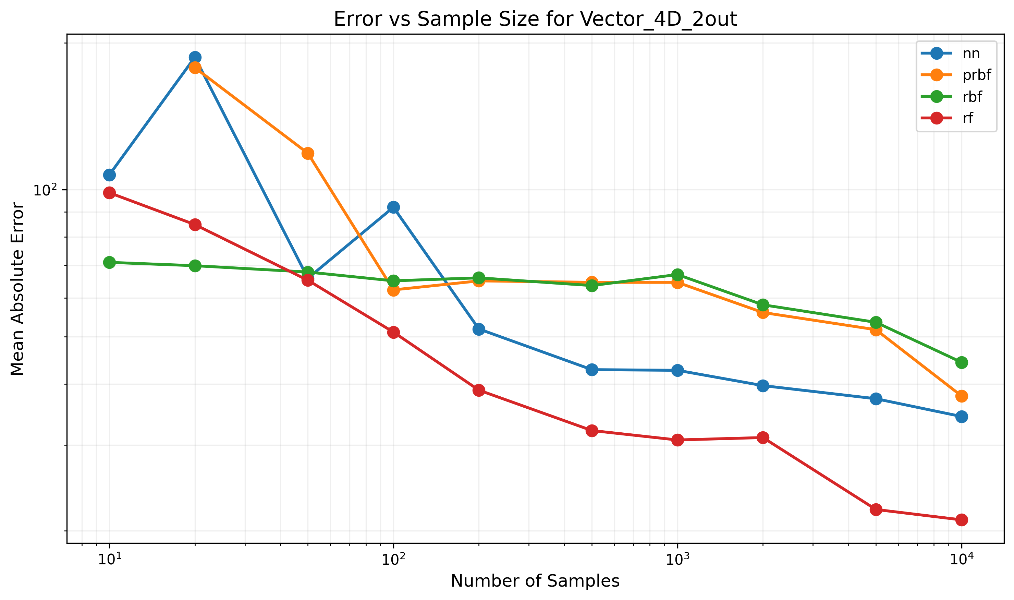

Figure: Error trends for Vector_4D_2out function

## Function: Vector_4D_3out

Dimensions: 4D -> 3D

Formula: [x1, x2, x3 + x4]

|  |  |  |  |  |  |  |  |  |  |  |
| --- | --- | --- | --- | --- | --- | --- | --- | --- | --- | --- |
| Model Type | 10 samples | 20 samples | 50 samples | 100 samples | 200 samples | 500 samples | 1000 samples | 2000 samples | 5000 samples | 10000 samples |
| nn | 339.44% | 44.92% | 219.34% | 241.46% | 225.11% | 245.53% | 224.90% | 220.96% | 236.10% | 219.97% |
| prbf | FAIL | 0.00% | 0.00% | 0.00% | 0.00% | 0.00% | 0.00% | 0.00% | 0.00% | 0.00% |
| rbf | 554.89% | 549.03% | 553.96% | 542.87% | 556.80% | 538.29% | 533.93% | 530.57% | 456.18% | 361.02% |
| rf | 262.81% | 192.08% | 94.10% | 78.46% | 42.81% | 24.88% | 16.50% | 11.68% | 9.77% | 4.81% |

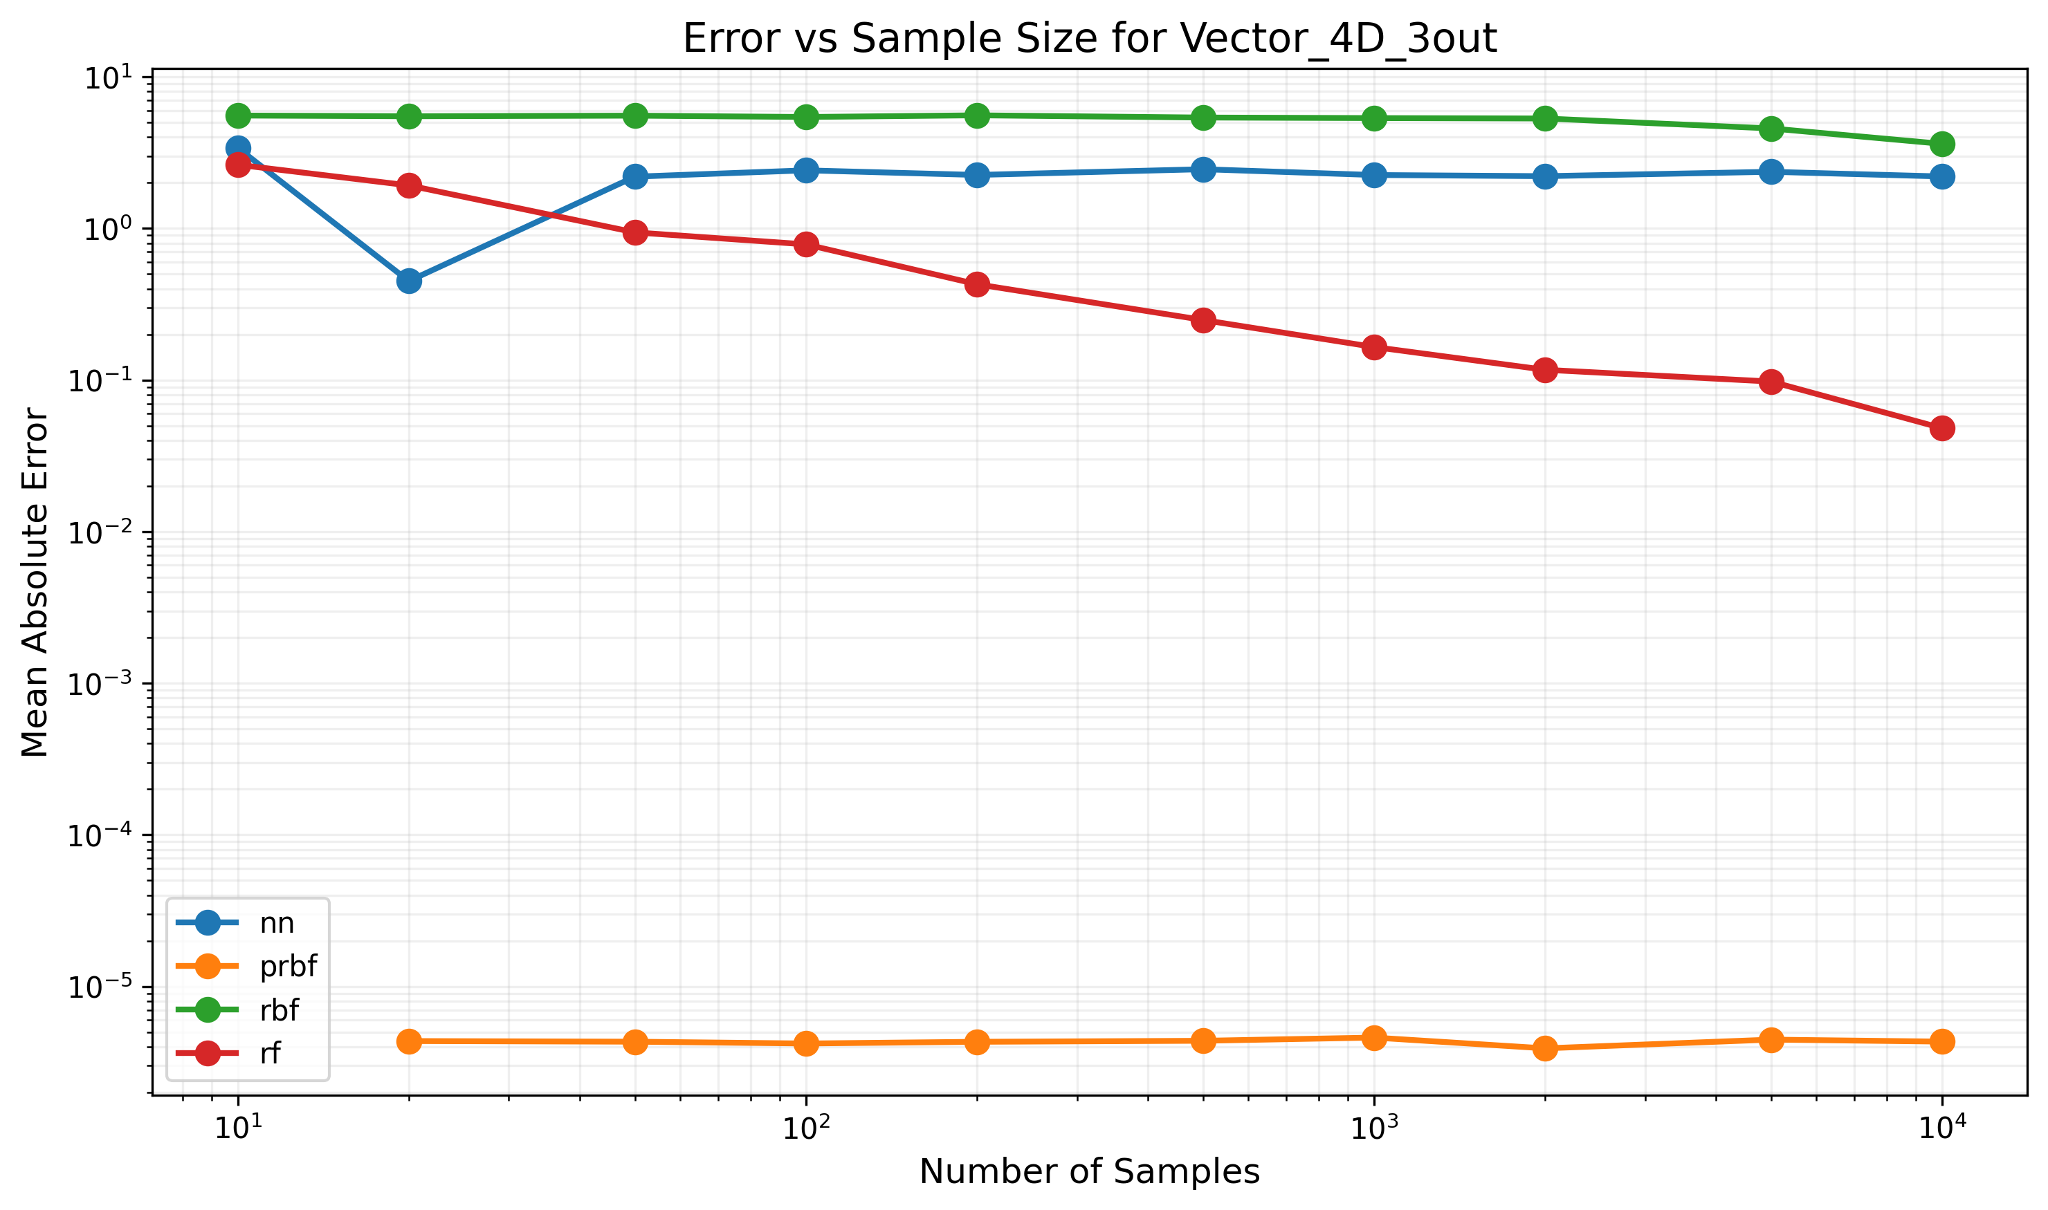

Figure: Error trends for Vector_4D_3out function

## Function: Vector_5D_2out

Dimensions: 5D -> 2D

Formula: [x1 + x2 + x3, x4 * x5 + x3]

|  |  |  |  |  |  |  |  |  |  |  |
| --- | --- | --- | --- | --- | --- | --- | --- | --- | --- | --- |
| Model Type | 10 samples | 20 samples | 50 samples | 100 samples | 200 samples | 500 samples | 1000 samples | 2000 samples | 5000 samples | 10000 samples |
| nn | 2166.41% | 1334.63% | 926.04% | 1038.84% | 1039.49% | 815.75% | 876.65% | 818.25% | 837.96% | 757.40% |
| prbf | FAIL | FAIL | 0.00% | 0.00% | 0.00% | 0.00% | 0.00% | 0.00% | 0.00% | 0.00% |
| rbf | 1728.47% | 1757.85% | 1675.99% | 1610.02% | 1677.07% | 1713.85% | 1689.33% | 1726.67% | 1692.31% | 1670.12% |
| rf | 1922.82% | 2134.25% | 1176.39% | 898.72% | 527.66% | 352.19% | 268.93% | 257.53% | 185.03% | 174.26% |

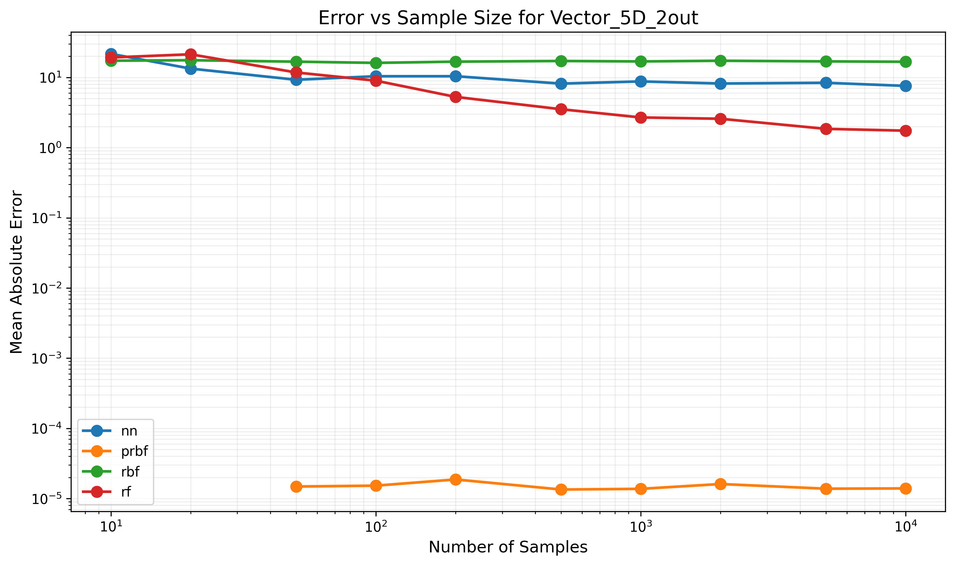

Figure: Error trends for Vector_5D_2out function

## Function: Vector_5D_3out

Dimensions: 5D -> 3D

Formula: [x1 + x2, x3 * x4, x5^2]

|  |  |  |  |  |  |  |  |  |  |  |
| --- | --- | --- | --- | --- | --- | --- | --- | --- | --- | --- |
| Model Type | 10 samples | 20 samples | 50 samples | 100 samples | 200 samples | 500 samples | 1000 samples | 2000 samples | 5000 samples | 10000 samples |
| nn | 4101.69% | 1112.54% | 1539.57% | 1400.48% | 1213.18% | 949.51% | 923.92% | 871.51% | 1015.40% | 976.34% |
| prbf | FAIL | FAIL | 0.00% | 0.00% | 0.00% | 0.00% | 0.00% | 0.00% | 0.00% | 0.00% |
| rbf | 2158.96% | 2052.23% | 2198.85% | 2155.35% | 2170.68% | 2135.90% | 2146.50% | 2098.75% | 2209.98% | 2117.88% |
| rf | 2698.02% | 1480.12% | 811.47% | 682.58% | 433.60% | 197.77% | 121.53% | 96.52% | 53.89% | 51.64% |

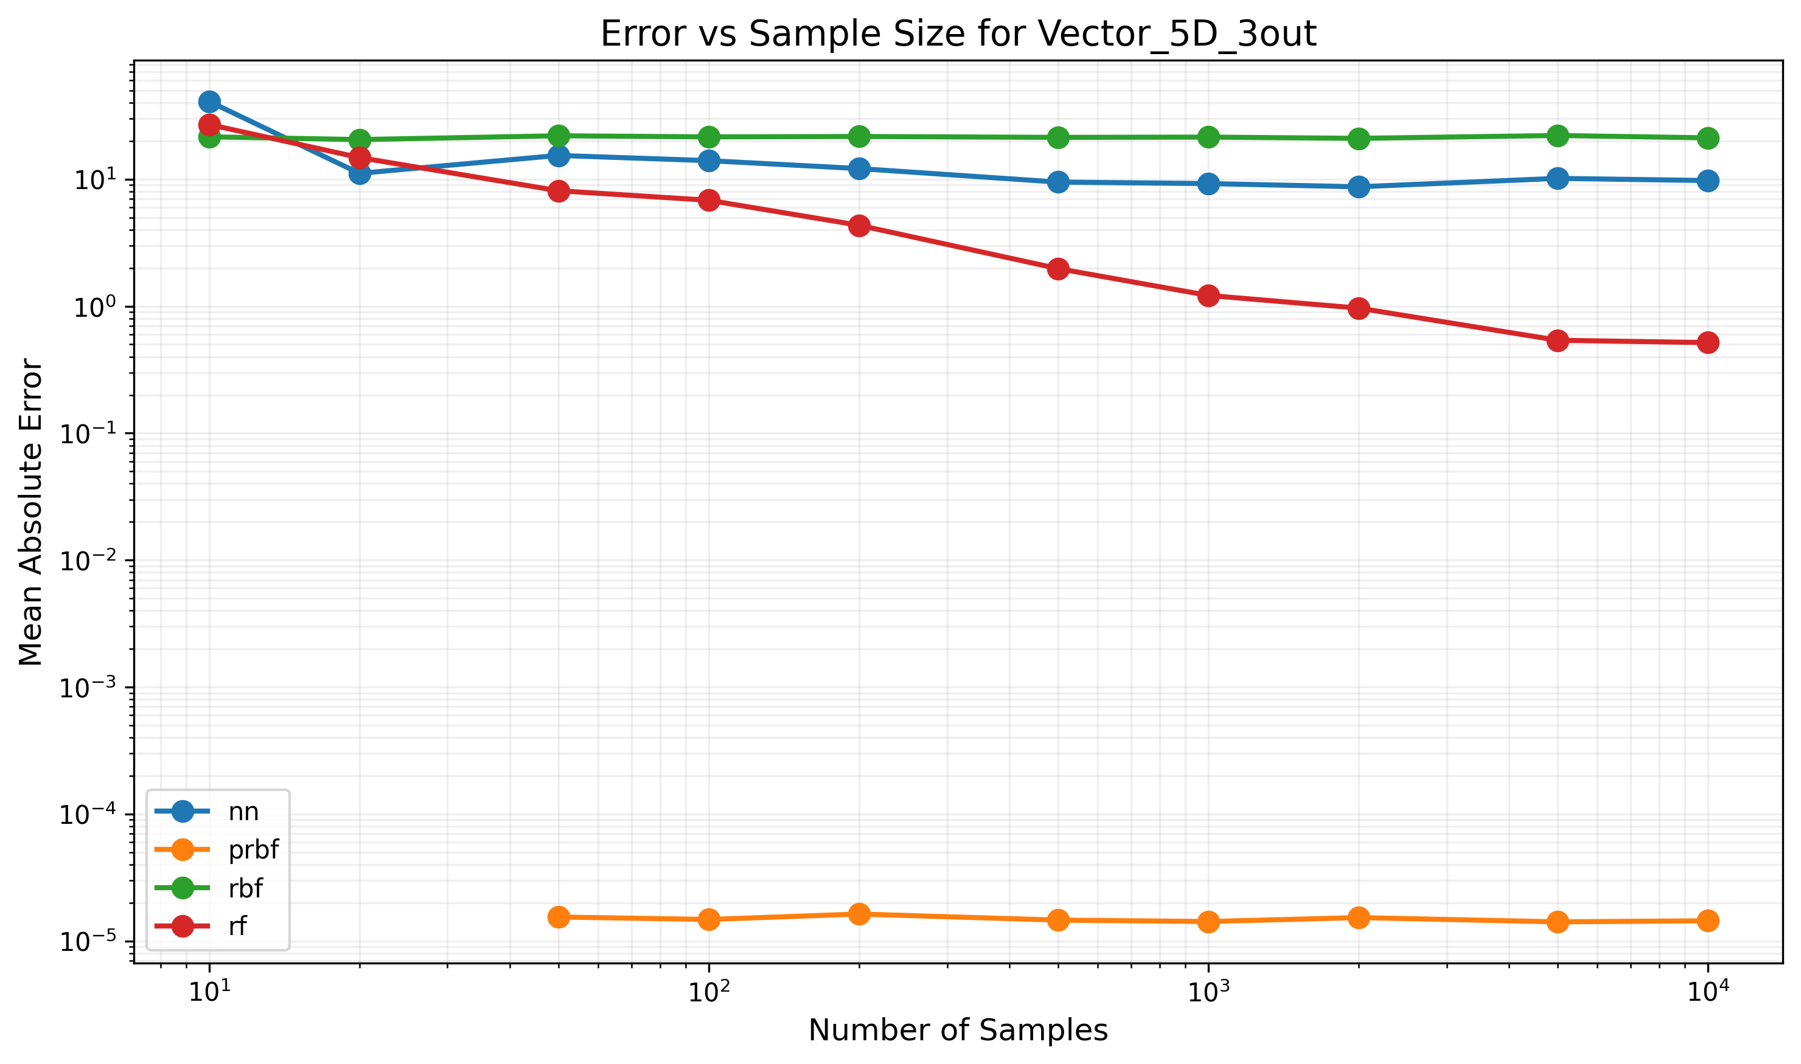

Figure: Error trends for Vector_5D_3out function